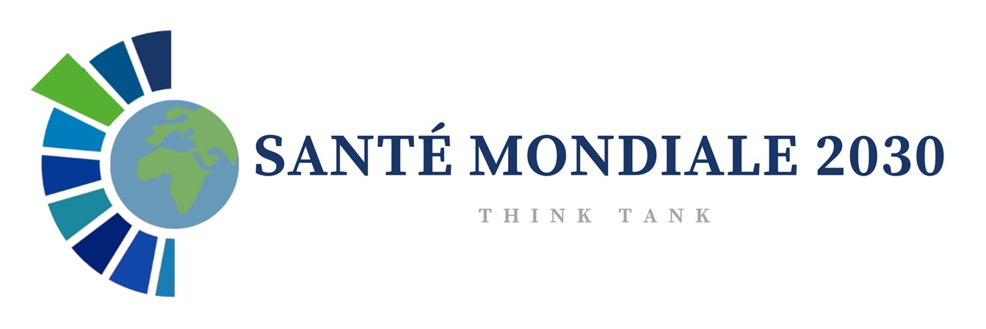

2000-2020 :
Two decades of changes in global health
April 14, 2024

This diagnostic document from the Think Tank "Santé mondiale 2030" was written by some of its members: François Dabis, Agnès Soucat, Eric Fleutelot, Annabel Desgrées du Lou, Marie-Paule Kieny, and its coordinators Stéphanie Tchiombiano and Clara Ruault. Other contributors include Anne Bekelynck, Margaux Chavardès, Mathias Altman, Fatoumata Faye and Zeinabou Niame Daf.

The graphics have been left in the original language (French).

Table of contents
Executive summary 4
1. Fragile and uneven demographic progress 6
1.1 A significant reduction in maternal, neonatal and infant/child mortality worldwide 6
1.1.1 Global downward trends, boosted by significant but insufficient progress in Sub-Saharan Africa and South Asia 6
1.1.2 Worrying trend breaks in high-income countries 9
1.1.3 The rise of vaccination: a decisive factor in reducing infant and child mortality 10
1.1.4 Life expectancy on the rise overall, albeit very uneven and fragile 12
1.2 Demographics: A growing and aging world population 14
1.2.1 Changing demographic balances 14
1.2.2 An aging world population 14
2 Communicable and non-communicable diseases: fragile gains 16
2.1 Infectious diseases: major changes since the beginning of the 21st century 16
2.1.1 HIV/AIDS: two decades of battle with major successes 16
2.1.2 Tuberculosis: significant progress, but not fast enough 19
2.1.3 Malaria: still essentially an African disease 21
2.1.4 Viral hepatitis: a forgotten disease 23
2.1.5 The rise of emerging and re-emerging infectious diseases 24
2.2 Non-communicable diseases (NCDs) on the rise worldwide 26
2.2.1 Cardiovascular disease: the world's leading cause of death 27
2.2.2 Diabetes: a meteoric rise in mortality 27
2.2.3 Cancers: increasingly diverse risk factors and populations 28
2.2.4 Mental health: diseases that are still largely neglected 30
2.2.5 The need to invest today in the prevention and management of non-communicable diseases 31
3 Global health under pressure from climate and environmental crisis 31
3.1 The impact of the climate and environmental crisis on health and its determinants 32
3.2 Zoonoses, a marker of the link between human, animal and environmental health 34
4 Progress towards Universal Health Coverage has stagnated or even regressed since 2015 35
4.1 Progress in health services coverage stalled at a plateau 36
4.2 Financial protection for populations worsening 38
4.3 Health funding has increased steadily over the past twenty years, but is very unevenly distributed 41
4.4 Access to health products is still inadequate, despite historic advances 46
4.5 Health professionals, a central issue between shortage and technological revolution 47
Outlook 52
Bibliography 54
Introduction

Over the past two decades, global health has undertaken profound transformations, the international community confronting increasingly complex challenges. The emergence and re-emergence of infectious diseases, amplified by the globalization of trade and travel, have amplified the need for greater international cooperation. The consequences of climate change have also exerted growing pressure on global health, increasing the frequency of extreme weather events and affecting environmental determinants.
The international community has responded to these challenges. A new institutional architecture has emerged, accompanied by unprecedented financial mobilization dedicated to global health. The Millennium Development Goals (MDGs) implemented between 2000 and 2015, marked a crucial first step, followed by the Sustainable Development Goals (SDGs) from 2015 onwards. These initiatives have guided global efforts, with the objective of improving access to health, reducing inequalities and tackling global health challenges.
However, despite undeniable progress, persistent challenges remain. In 2020, the COVID-19 pandemic highlighted the vulnerability of global health systems and the need for increased preparedness for emerging health threats. Growing antimicrobial resistance and persistent inequalities in access to health services also increasingly call for urgent and continued action.
This document summarizes two decades of global health changes between 2000 and 2020. This analysis is not intended to be exhaustive, but rather to offer an overall vision of the main trends, and particularly highlighting the progress made over these two decades, in order to better identify the gaps, the margins for progress, and the warning points that call into question some of the progress made. We wanted to bring together scattered data, too often analyzed "in silo", by disease or theme, to bring them into dialogue and lay the foundations for a more global reflection on global health issues.
From a methodological point of view, the two decades 2000-2009 and 2010-2019 constitute the reference period for our analyses. We extended the examination of certain statistics available for the years 2020 and 2021 where this made sense, but in general, we considered mainly the evolution of indicators up to 2019, the end of the second decade. The COVID-19 pandemic interrupted or even reversed positive trends observed over almost twenty years, possibly marking the end of a global health cycle.
This assessment is essentially based on information drawn from databases and reports produced by international organizations - notably the UN - and by national statistical agencies, which we consider to be the most consensual and well-documented sources for analyzing secular trends over this period. We have also drawn on results published in the scientific literature, as well as - where no other sources were available - modelling data produced by the Institute for Health Metrics and Evaluation (IHME, Seattle, USA).

Executive summary

Global health made significant progress in the last two decades. Life expectancy has risen significantly, from 66.8 to 73.4 years, a remarkable gain of 6.6 years. Maternal mortality declined, particularly in sub-Saharan Africa and South Asia, and under-five mortality decreased even more strikingly , with an overall drop of 52%.
Impressive results in terms of mortality from certain infectious diseases catalyzed this progress. These include a significant 68% drop in the number of HIV/AIDS-related deaths and the eradication of malaria in 11 countries over the past two decades. However, the second decade (2010-2020) has seen a slowdown in health progress, raising concerns about its universality and sustainability. Progress is unevenly spread across countries and populations, and its reversibility is a constant cause for concern.
This document attempts to conduct an in-depth diagnosis of the main trends in health indicators, highlighting the progress made and analyzing the causes of their fragility:

The first part of the document highlights significant progress in terms of life expectancy and maternal and infant mortality, while pointing to signs of regression. Progress remains highly uneven geographically. The situation in sub-Saharan Africa remains a cause for concern, as this region will not achieve the targets set by the 2030 SDGs. In terms of demographic transition, fertility remains high, and Africa's population is set to double by 2050 to over 2 billion. Meanwhile, in the rest of the world, the overall ageing of the population is increasingly creating new needs (chronic diseases, increasing number of years of life with disability, etc.).

The second part provides an overview of trends in the main causes of morbidity and mortality. While infectious and perinatal diseases remain the main causes of death in low-income countries, undeniable progress has been made over the last twenty years in mortality rates due to the three major pandemics (HIV/AIDS, tuberculosis and malaria). HIV/AIDS mortality has fallen by 66%, but the incidence of infection is rising in countries that have historically been less targeted and therefore less equipped with control mechanisms, namely Eastern Europe and Central Asia. Tuberculosis still causes 1.6 million deaths a year, far from the targets set by the SDGs. Malaria remains a predominantly African problem, with four countries accounting for half of all cases worldwide (Nigeria, Niger, DRC, Tanzania). Some 350 million people live with chronic hepatitis, and inequalities persist in access to diagnosis and treatment.
Low-income countries face a "double burden" of diseases (infectious and non-communicable). While high-income countries have undertaken a transition from infectious to chronic diseases over the past 20 years, this evolution is far from uniformly repeated worldwide. Deaths from cardiovascular disease, the world's leading cause of mortality, are now mostly concentrated in developing countries, which are generally less equipped with early detection systems and continue to face the burden of infectious diseases. The prevalence of diabetes has tripled in two decades, a particularly worrying trend in the Pacific and South-East Asia. The global food transition towards ultra-processed products is largely responsible for these trends.

The third part of the document focuses on the effects of the climate and more generally of the environmental crises on health. Climatic and environmental upheavals increase the risk of emerging infectious diseases, such as zoonoses, by disrupting ecosystems and human-animal interactions. They also affect all health determinants, from air and water quality to exposure to natural disasters and the availability of healthy, sufficient food. They are also responsible for chronic diseases, such as cancers and respiratory ailments, linked to widespread air pollution. The number of heat-related deaths could increase fivefold by 2050, mainly in the world's poorest and already hottest regions.

The fourth part shows that health system coverage has improved in recent decades, but that universal health coverage (UHC) is far from being achieved. UHC implies equitable access to health services and protection against the dramatic consequences of households having to bear health-related costs. But today, less than half the world's population has access to most essential health services. Significant inequalities persist in terms of service coverage, both between countries at different income levels, and within countries between socio-economic groups. Indeed, the poorest are less likely to be vaccinated and have less access to maternal and child health services than the richest. In addition, the population incurring catastrophic health-related costs has risen steadily worldwide since 2000, topping the one billion mark in 2019. There has also been a marked increase in impoverishment due to health expenditure among populations in relative poverty. COVID-19 has exacerbated these deficiencies, often manifesting themselves in foregone healthcare.
Access to medicines has made historic progress, spurred by civil society's efforts to make antiretroviral HIV drugs affordable. However, global and equitable access to health products is hampered by the rising cost of innovations (particularly in oncology), the use of intellectual property rights to drive up prices, monopolies, the weakness of states in price negotiations, and the concentration of production in wealthy countries.
Shortage of human resources for health is increasingly a global phenomenon. There are also major inequalities (2.3 doctors per 10,000 inhabitants in sub-Saharan Africa, compared with 39.4 in Europe), attributable both to problems of training and qualification, and to l new needs (linked to demographic changes, epidemiological transition and environmental crises, in particular).

Finally, the document's conclusion provide guidance for further reflection on the notion of global health, its actors and practices, particularly in terms of governance, health determinants, and the participation of societies in the promotion of sustainable universal health.

Fragile and uneven demographic progress

Analysis of the demographic dynamics of the world's population (ageing, fertility) provides a better understanding of changing health-related needs. This first part traces the evolution of the main health indicators linked to these dynamics, in particular maternal, neonatal and infant/juvenile mortality, as well as life expectancy.

box 1 - key points on demographic trends
- Over the past 20 years, maternal, neonatal and infant/child mortality has fallen significantly worldwide, even if the indicators for South Asia and sub-Saharan Africa are still far from meeting the SDGs.
- In some high-income countries, such as the United States, there are worrying trends in terms of rising maternal mortality and falling life expectancy.
- In Africa, life expectancy has risen particularly sharply, with an average gain of 10 years over two decades, but it is still low (63 years) compared to the world average (73 years).
- The ageing and fertility country profiles are very mixed, with high and middle-income countries facing significant population ageing, and low-income countries still facing high fertility and very young populations. 42% of Africa's female population is under 15.

A significant reduction in maternal, neonatal and infant/child mortality worldwide

At the onset of the 21st century, maternal, neonatal and child mortality (see definitions in Box 2) was still very high in many parts of the world, especially in South Asia and sub-Saharan Africa, in contrast to wealthier countries. During the first two decades of the 21st century, maternal, neonatal and infant/child mortality fell significantly in these two regions, influencing global trends in a major way.

Box 2 – mortality classification
- Maternal mortality: deaths of women during pregnancy and in the 42 days following childbirth.
- Neonatal mortality: deaths of children under 28 days
- Infant mortality: deaths of children under one year
- Infant mortality: deaths of children under five years

Global downward trends, boosted by significant but insufficient progress in Sub-Saharan Africa and South Asia

Between 2000 and 2020, the progress achieved in reducing maternal mortality (number of maternal deaths per 100,000 live births) is indisputable (Figure 1), with a worldwide drop in maternal mortality rate of around 34%. Nevertheless, the level of maternal mortality is very uneven across the world. In 2020, the maternal mortality rate in low-income countries was 430 per 100,000 live births, compared with 12 per 100,000 live births in high-income countries. Almost 95% of maternal deaths, most of which could have been avoided, occurred in low- and middle-income countries. (3). Although sub-Saharan Africa has seen the greatest overall decline in maternal mortality rate (33%), and despite a potential for progress that remains very significant today, the average annual decline in maternal mortality has been lower than in South Asia, with an average annual rate of decrease of 3% versus 5.4%. This situation is partly linked to changes in the number of births in these two parts of the world, with South Asia recording almost half as many births as sub-Saharan Africa between 2000 and 2020.

Figure 1 - Trends in maternal mortality by world region, 2000-2020(4)

However, if these trends continue, the SDG targets of fewer than 70 maternal deaths per 100,000 live births (SDG3) will be difficult to achieve by 2030 for both regions. In South Asia, it is estimated that the target could be reached by 2033, while in sub-Saharan Africa it would still take more than 50 years.
The reduction in neonatal mortality has also been significant over the same period, with the neonatal mortality rate almost halved worldwide between 2000 and 2019, from 30 to 17.5 neonatal deaths per 1,000 live births. In 2000, neonatal mortality was highest in South Asia (46 deaths per 1,000 live births), a situation partly explained by the high prevalence of low birth weight in this region. The situation was only slightly better in sub-Saharan Africa, where this indicator reached 40 deaths per 1,000 live births. Since 2014, the highest rates have been observed on the African continent, but they are still far too high in both regions (Figure 2). The target of fewer than 12 neonatal deaths per 1,000 live births (SDG3 target 3.2) (5) has already been achieved elsewhere in the world.

Figure 2 - Trends in neonatal mortality by world region, 2000-2020 (6)

Gains in infant and child mortality over the last twenty years are much more marked than for neonatal mortality (Figure 3), and the trend is fairly uniform across all regions of the world. This represents a 52% gain over the period, due to improved immunization coverage and better prevention and treatment of malaria and diarrheal diseases. However, the SDG target of fewer than 25 deaths per 1,000 live births by 2030 (target 3.2 of SDG3 (5)) will be extremely difficult to achieve on the African continent, as highly populated countries such as Nigeria, and very fragile ones such as Chad, the Central African Republic and Somalia, are no longer making progress in this area, or are even reporting reversals in the trend.

Figure 3 - Trends in infant and child mortality by world region, 2000-2020 (4)

Worrying trend breaks in high-income countries

These disappointing results are not confined to the poorest countries. Maternal mortality deteriorated in eight countries over the two decades. The United States had the sharpest increase of all during the 2000-2015 MDG cycle (1). Between 2000 and 2020, maternal mortality in the world's leading economic power rose from 12 to 21 per 100,000 live births, an unprecedented increase of 78%, with very marked territorial, racial and socio-economic disparities.

France is not totally spared either, if we examine the trend in infant mortality among industrialized countries. While France had enjoyed unprecedented success since the 1970s in reducing its infant mortality, the downward trend in infant mortality (from birth to the first birthday) has reversed since 2012, and seems largely influenced by the unfavorable trend in early neonatal mortality, during the first week of life (Figure 4). Several factors may explain this phenomenon: rising maternal age, increasing prevalence of overweight and smoking, as well as poverty and precariousness among migrant women.

Figure 4 - Infant mortality trends in France, 2000-2019 (7)
In countries at all income levels, if ambitious public policies aimed at reducing social inequalities and investing sustainably in maternal and child health are not put in place, there is a significant risk that the positive results observed to date will not be sustained.

The rise of vaccination: a decisive factor in reducing infant and child mortality

Programs to reduce avoidable infant and child mortality have been implemented during the second part of the century in most regions of the world. These programs have combined targeted and biomedical interventions, most often as part of vertical programs (family planning, combating malaria and diarrheal diseases, immunization, in particular), with structural investments in health systems (MCH clinics and health workers delivering prenatal and neonatal care in particular). Increased levels of education for girls and women, as well as a general improvement in living conditions during this period, have also had a positive effect on these various indicators.
Among these interventions, vaccination is recognized as one of the most effective public health measures, having contributed significantly to favorable trends in infant and child mortality. Over the past two decades, vaccination coverage has increased significantly overall, although it has stagnated since the 2010s, with a brutal decline due to the COVID-19 crisis from 2020 onwards. For example, the proportion of children vaccinated against diphtheria, tetanus and pertussis (DTP) and measles rose from 73% to 86% between 2000 and 2019, and the hepatitis B vaccination rate for children under 1 year of age rose dramatically from 30% to 86% over the same period (Figure 5). As a result, this trend is also reflected in the number of "zero-dose" children, i.e. children who have not received any routine vaccinations, which fell sharply until 2019, before rising worryingly again from 2020 onwards (Figure 6).
Epidemics of measles, diphtheria and yellow fever have increased in recent years, as have the number of cases of paralysis attributed to poliomyelitis, forcing a review of the eradication strategy, currently postponed until 2026. The COVID-19 epidemic also revealed chronic production and supply problems, as manufacturers turned away from producing less profitable vaccines to meet the colossal demand for anti-Covid vaccines, jeopardizing the fight against certain diseases such as cholera.

Figure 5 - Trends in combined diphtheria-tetanus-pertussis (DTP), hepatitis B and measles vaccination rates worldwide (2000-2021) (8)

Figure 6 - Number of "zero-dose" children worldwide (2000-2021) (8)
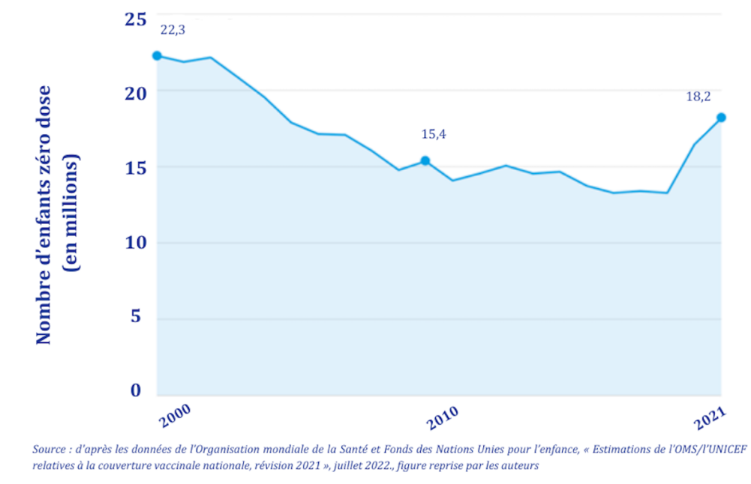

Vaccination coverage is also marked by major inequalities, both between and within countries. For example, in 2022, DTP vaccine coverage was over 90% in high- and high-middle-income countries, over 80% in low-middle-income countries and just over 70% in low-income countries, the latter having been further weakened by the COVID-19 crisis (Figure 7). In Angola, Nigeria and Papua New Guinea a child from the wealthiest social economic quintile is five times more likely to be vaccinated than a child from the poorest quintile.

Figure 7 - Basic immunization coverage (DTP-3rd dose) in countries by income group (9)

Life expectancy on the rise overall, albeit very uneven and fragile

Globally, life expectancy rose by 6.6 years between 2000 and 2019, from 66.8 to 73.4 years, while healthy life expectancy increased more slowly, by 5.4 years. Thus, the gain in mortality reduction has not been matched by a comparable gain in years lived free of disability. Globally, the same trends can be observed in all regions of the world (except Oceania), with an overall increase in life expectancy from 2000 to 2019, followed by a decrease between 2019-2021 linked to the COVID-19 epidemic (with a loss of 1.8 years worldwide) (Figure 8).
This increase varies from country to country, with virtual stagnation in the Americas, a gain of five years in Europe, and an increase of almost 10 years in Africa over the same period. However, Africa was also the continent with the lowest life expectancy in 2000 (53 years). At that time, the HIV/AIDS epidemic was uncontrolled, with devastating effects, while the impact of programs to reduce maternal and infant mortality was still limited.

Figure 8 - Trends in life expectancy at birth by world region, 2000-2021 (10)

In the USA, the situation is particularly worrying. At the end of 2021, life expectancy at birth had fallen to 76.4 years, a drop of 2.7 years in two years, with major social inequalities between ethnic groups, to the detriment of American Indians, Alaska Natives and African-Americans (Figure 9). While this deterioration is partly attributable to COVID-19 and its poor management, it is also linked to high socio-economic and racial inequalities, weak social protection, the impact of obesity on health, increased violence and the sharp rise in overdose deaths during the epidemic.

Figure 9 - Evolution of life expectancy in the United States by gender and ethnic group (11)
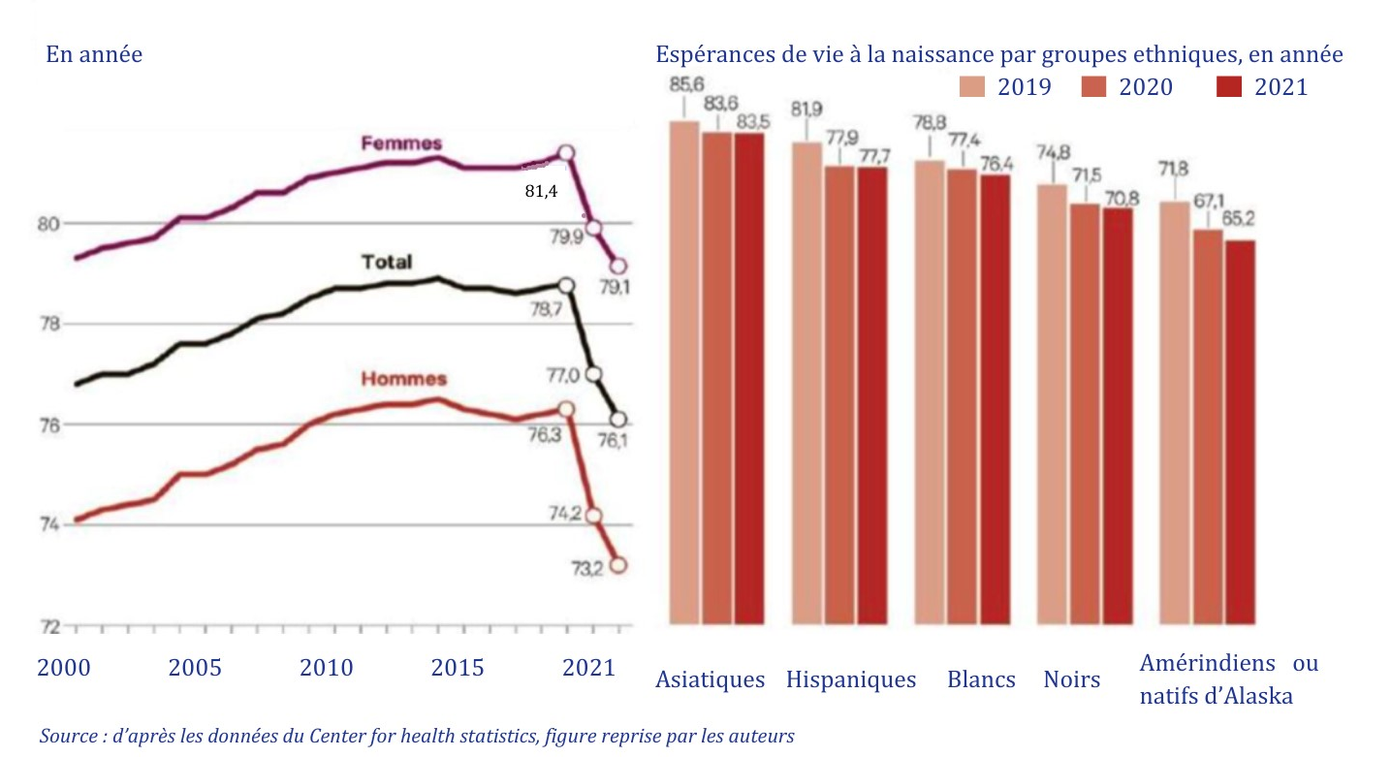

Demographics: A growing and aging world population

Changing demographic balances

Although the number of living human beings has just exceeded eight billion, demographic dynamics are far from homogeneous on a global scale. (12). The populations of some countries are continuing to grow, sometimes at very significant rates, as in sub-Saharan Africa, where the population is set to almost double by 2050, while others are seeing their populations stagnate, as in Europe and North America (an anticipated 0.4% increase by 2050), or even decline, as in China, whose population is set to fall by 110 million between 2022 and 2050 (i.e. almost 8%), gradually caught up by India (Figure 10).
World population growth, which remains heavily dependent on a few countries (Democratic Republic of Congo, Egypt, Ethiopia, India, Nigeria, Pakistan, Philippines, Tanzania, in descending order of expected increase), is set to peak at 10.4 billion in 2080. (12).

Figure 10 - Population estimates for 1950-2022 and projections by region to 2050 (12)
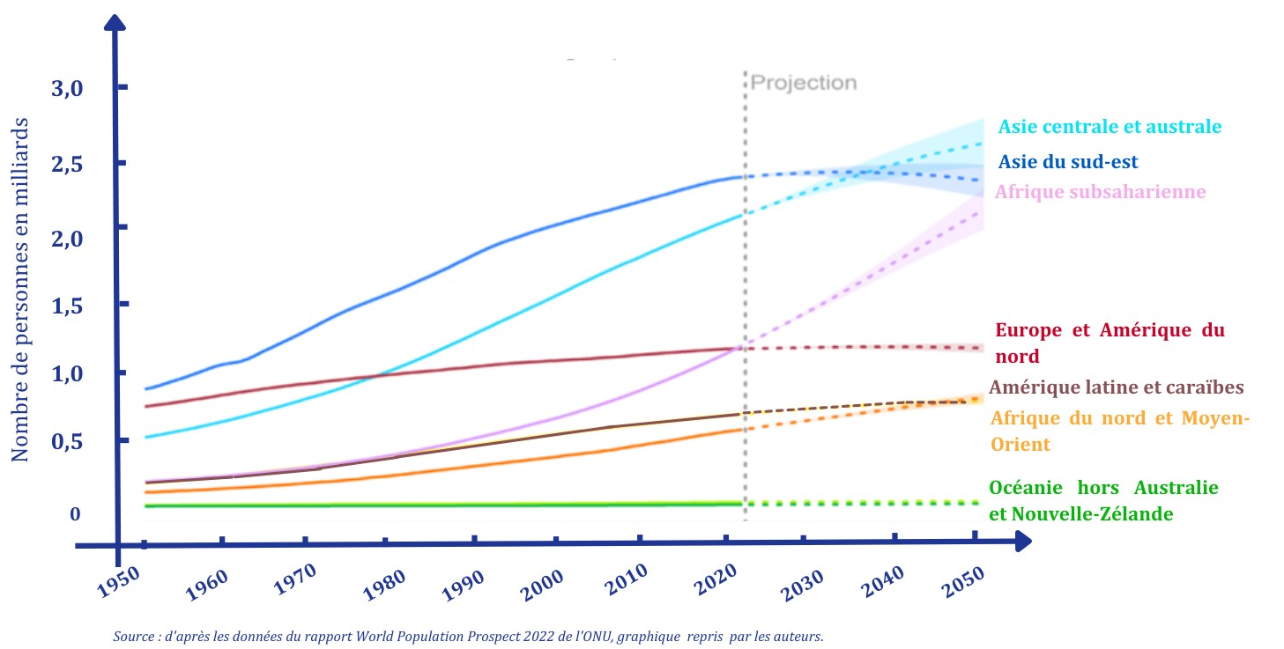

An aging world population

The world's population has never been so old, and this dynamic is set to intensify in the years ahead. By 2050, one in six people worldwide will be over 65 (16%), compared with one in 10 in 2022 (10%). Strong regional disparities can be observed, with 41% of the female population in Europe and North America over 50, while this age group represents only 10% of women in sub-Saharan Africa (Figure 11). While the ageing of the population is evolving at different rates in different regions and countries, it has become a central issue for public policy, with major repercussions on health-related needs and the organization of health systems.

Figure 11 - Distribution of female population, by age, in 2020 (13)
The global fertility rate fell from 2.7 children per woman in 2000 to 2.3 in 2020, and is set to fall further to 2.1 in 2050. The number of children per woman remains particularly high in certain regions, notably sub-Saharan Africa (4.6 on average) and in countries such as Niger (7,8). The demographic transition is thus far from complete in most sub-Saharan African countries.
Conversely, the fertility rate remains below the population reproduction threshold in almost all high-income countries, which are subject to significant ageing phenomena, with all the social, economic and health consequences this entails, including an increase in chronic and non-communicable diseases. Yet the health risks associated with these population dynamics are often insufficiently taken into account by public policies.

Communicable and non-communicable diseases: fragile gains

Box 3 - Key points on the evolution of communicable and non-communicable diseases
- The main epidemiological monitoring indicators show that the fight against the infectious diseases prioritized by the international community (HIV/AIDS, tuberculosis, malaria) has seen major progress over the last 20 years, albeit with a break linked to the COVID-19 epidemic.
- The fight against the HIV/AIDS epidemic has been an undeniable success over the past two decades, with a 54% drop in incidence and a 66% drop in mortality attributable to HIV/AIDS, but this progress is insufficient to hope to achieve control of the epidemic by 2030.
- In 2021, tuberculosis was still responsible for 1.6 million deaths a year, three times more than HIV/AIDS.
- In 20 years, 11 countries have been able to eradicate malaria. By 2021, Africa accounted for 95% of malaria cases worldwide. Half of all malaria deaths were concentrated in four countries (Mozambique, Nigeria, Democratic Republic of Congo, Tanzania).
- Around 296 million people live with chronic hepatitis B and 58 million with chronic hepatitis C (2019). Significant progress has been made, with improved vaccination coverage against hepatitis B and the discovery of a cure for hepatitis C in 2014. However, access to diagnosis and treatment is still extremely low, at 21% and 13% respectively among people infected with the hepatitis C virus, and 10% and 2% with the hepatitis B virus.
- Emerging or re-emerging infectious diseases have (re)emerged as global health issues since the beginning of the 21st century, due to the evolution of pathogens, environmental changes and the impact of human behavior.
- The COVID-19 epidemic caused nearly 18 million deaths in 2020-2021.
- Mortality from non-communicable diseases (NCDs) has risen by 30% in 20 years.
- Over the last twenty years, the prevalence of diabetes has tripled, while the number of cancer-related deaths has risen from 6 to 10 million a year.

Infectious diseases: major changes since the beginning of the 21st century

Today, infectious diseases no longer represent the main cause of mortality worldwide, but they are still responsible for several million deaths every year in developing countries, where six out of 10 deaths are infectious.

HIV/AIDS: two decades of battle with major successes

Table 1 summarizes the three main epidemiological indicators: prevalence, incidence and mortality attributable to HIV/AIDS at the beginning and end of the period worldwide.

Table 1 - Estimates for HIV/AIDS in the world in 2000 and 2020 (14,15)
 | 2000 | 2020
Number of people living with HIV (PLHIV) | 26,6 M | 37,7 M
Number of new infections per year (in millions) | 2,8 M | 1,5 M
Annual number of HIV/AIDS-related deaths | 1,7 M | 680.000
Number of PLHIV who know their serostatus | <10% | 84%
Number (%) of PLHIV on antiretroviral treatment | ~ 3% | 73%
Number (%) of PLHIV with controlled viral load | ND | 66%

The dynamics of HIV transmission peaked in 1997, with an incidence of 3.7 million new infections per year. Since then, the curve has reversed, falling to 1.5 million new HIV infections in 2020, a drop of 54%. While this major inflexion demonstrates the success of the fight against HIV/AIDS, the incidence of new infections remains three times higher than the target set in the SDGs, since objective 3.3 anticipated that by 2020 there would be only 500,000 new infections per year to end the epidemic by 2030. What's more, the COVID-19 epidemic has had a major negative impact on the implementation of HIV/AIDS programs, in terms of prevention, screening and access to treatment, in a context of inflation and stagnation in international aid dedicated to HIV/AIDS, with ever-increasing treatment needs. Effective and lasting control of the epidemic by the end of this decade therefore seems unlikely.
In terms of mortality attributable to HIV/AIDS, the results are significantly better than for HIV transmission. The peak in HIV/AIDS-related deaths was observed in 2004 (2 million per year), and by 2020, 680,000 deaths had been recorded, representing a 66% drop. The intermediate SDG target of 500,000 deaths by 2020 has thus almost been reached. This clear progress can be attributed to access to antiretroviral drugs in most of the countries particularly affected, enabling HIV-infected patients to live longer in good health. In 2000, only 685,000 people living with HIV were on antiretroviral treatment; by 2020, the figure will have risen to 27.4 million. However, the reduction in the annual number of deaths is less and less marked, year after year, suggesting that the 2025 and 2030 targets will be difficult to achieve.
Analysis of incidence and mortality trends by world region between 2010 and 2020 reveals marked contrasts in terms of epidemic control (Figure 12). In the regions historically most affected, the reduction in new infections has been the greatest: 43% in Eastern and Southern Africa and 37% in West and Central Africa. Conversely, during the same period, incidence rose by 43% in Eastern Europe and Central Asia, the only region in the world where the epidemic, concentrated in "key populations" - particularly among drug users, who accounted for 43% of new infections in 2021 - continued to soar. Similar trends were observed in terms of HIV/AIDS-related mortality, with an increase of a third in Eastern Europe and Central Asia, while it fell by 47% worldwide.

Figure 12 - Ten-year change (2010-2020) in HIV incidence and HIV/AIDS mortality by world region (17)

Over the last twenty years, unprecedented successes have been achieved in controlling the HIV/AIDS epidemic, which can be directly linked to the massive international political commitment and financial efforts made worldwide . Highly effective interventions with a high level of evidence have been scaled up in countries affected by the epidemic. The combination of combined prevention approaches (behavioral and biomedical) with the generalization of HIV/AIDS screening and antiretroviral treatment has enabled this massive drop in HIV/AIDS incidence and mortality. Nevertheless, the dynamics of the epidemic remain strong. Continuing high incidence coupled with falling mortality is leading to a steady increase in the number of people living with HIV worldwide, currently around 38 million. In the absence of a preventive vaccine and/or the possibility of a cure once infection has been contracted, immediate and ongoing care, in particular via antiretroviral treatment, continues to be needed if we are to continue to reduce transmission of the virus and sustainably control the epidemic. The geographical, gender, age and social inequalities observed require responses tailored to the different populations concerned. This calls for ever greater national and international investment, guaranteed over the long term.
Finally, the deleterious trends observed in Eastern Europe and Central Asia show just how fragile the gains made in the fight against the epidemic are, and how necessary it is to maintain a solid and relentless action to avoid any epidemic resurgence.

Tuberculosis: significant progress, but not fast enough

Global epidemiological indicators for tuberculosis at the beginning and end of the period are shown in Table 2.

Table 2 - Estimates of tuberculosis worldwide in 2000 and 2020 (18)
 | 2000 | 2020
Number of TB cases per year (in millions) | 11 | 9,9
Incidence of TB  (Annual rate per 100,000 inhabitants) | 184 | 127
Number of TB-related deaths per year (in millions) | 1,7 | 1,5

Tuberculosis remains a global public health problem, despite a remarkable decline in the incidence rate over the last twenty years, of around 2% per year worldwide, from 184 to 127 cases per 100,000 inhabitants between 2000 and 2020. (19).
This long-term improvement is even more marked in sub-Saharan Africa and South Asia, where incidence rates have always been the highest in the world (Figure 13). In 2020, South and East Asia, notably India, Indonesia, China, the Philippines, Pakistan and Bangladesh, accounted for 43% of new tuberculosis cases, while sub-Saharan Africa accounted for 25%. Within the framework of SDG 3.3, the target of a 20% reduction in the incidence rate between 2015 and 2020 has been achieved by the Europe, Central Asia and North America regions, while the Africa, Middle East/North Africa and South Asia regions have seen incidence fall by 19%, 15% and 10% respectively.
Figure 13 - Incidence of tuberculosis (annual rate per 100,000 inhabitants) by world region, 2000-2020 (19)
However, unlike HIV/AIDS, it is above all in terms of mortality that the fight against tuberculosis seems to achieve its worst results. Although the key indicators (annual number of deaths and mortality rate) fell steadily between 2000 and 2019, they start to rise again from 2020, with the onset of the COVID-19 pandemic. Above all, the reduction in mortality is not fast enough, since it was only 5.9% between 2015 and 2021, whereas the WHO target is a 75% reduction in deaths between 2015 and 2025, which is now out of reach. In 2020, 1.5 million deaths were still attributable to tuberculosis, three times as many as to HIV infection. India accounts for around 1/3 of tuberculosis-related deaths worldwide.
This progress in the fight against tuberculosis over the last two decades has been achieved thanks to the discovery of major technical innovations (rapid molecular diagnostic tests replacing microscopic analysis of sputum smears, shorter treatment courses, availability of oral treatment regimens for drug-resistant tuberculosis, preventive treatment), combined with the implementation of various large-scale operational strategies (decentralization of services, active case and outbreak finding targeting key and vulnerable populations and settings with high disease prevalence, management of co-morbidities) .
The fight against tuberculosis suffered particularly badly from the health crisis linked to the COVID-19 pandemic and has since been slow to regain the direction set to achieve the SDGs in 2030. For example, diagnosis and notification of tuberculosis cases collapsed during the health crisis, falling from 7.1 million cases in 2019, to 5.8 million in 2020, and only recovering to 6.4 million cases in 2021. This suggests that the number of undiagnosed and untreated cases has increased, aggravating both the risk of transmission of infection and the risk of TB disease and death among those infected. The political declaration adopted at the high-level meeting on the sidelines of the United Nations General Assembly in September 2023 provides a more stimulating and ambitious framework for the next five years (20).

Malaria: still essentially an African disease

Global malaria epidemiological indicators at the beginning and end of the period are reported in Table 3.

Table 3 - Global malaria estimates for 2000 and 2020
 | 2000 | 2020
Number of malaria cases per year (in millions) | 245 M | 245 M
Incidence rate per 1,000 people in endemic areas | 82,3 | 59,4
Number of malaria-related deaths per year | 897.000 | 625.000
Mortality rate per 100,000 people in endemic areas | 30,1 | 15,1

Between 2000 and 2020, key malaria indicators showed significant progress worldwide. The incidence rate fell from 82.3 per 1,000 people at risk in 2000 to 59.4 in 2020, a drop of 28% in 20 years, including a slight upturn linked to COVID-19 in 2019-2020 (Figure 14.a).
In terms of mortality, the decline was steady from 2000 to 2015, halving the death rate over the period for people at risk. This trend then eased, leading to stable mortality between 2015 and 2021 (Figure 14.b).
Figure 14 - a) Incidence of malaria (annual rate per 1,000 people at risk), b) Mortality rate (per 100,000 people at risk) from 2000 to 2021(21)

Today, malaria is endemic in 91 countries around the world, but the disease undeniably remains a major problem for sub-Saharan Africa (Figure 15). Between 2000 and 2020, 11 countries will have completely eliminated malaria: the United Arab Emirates, Morocco, Turkmenistan, Armenia, Kyrgyzstan, Sri Lanka, Uzbekistan, Algeria, Argentina, Paraguay and China. The African continent now accounts for 95% of estimated cases worldwide. However, the decline in incidence has been substantial in Africa, with a 40% drop in 20 years, making a considerable impact on infant and child mortality, although 80% of malaria-related deaths on the continent still concern children under five (2021). West and Central Africa record the highest incidence rates in the region, with rates in excess of 300 per 1,000 people at risk in many countries (Benin, Burkina Faso, Central African Republic, Democratic Republic of Congo, Guinea, Liberia, Mali, Nigeria, Niger and Sierra Leone), while the average incidence rate in sub-Saharan Africa is 220 (22). In terms of mortality, four countries account for just over half of all malaria-related deaths worldwide, with Nigeria (31%), the Democratic Republic of Congo (13%), the United Republic of Tanzania (4%) and Niger (4%).

Figure 15 - Malaria-related deaths worldwide by region (2000-2020) (21)

Over the past two decades, substantial scientific advances have been made and implemented on a very large scale in prevention, diagnosis and management, such as the new generation of insecticide-treated mosquito nets, intra-domiciliary insecticide spraying and chemoprevention of seasonal malaria in children under five. The WHO's recent recommendations for the use of RTS,S/AS01 - Mosquirix (2021) and R21/Matrix-M (2023) vaccines in children living in regions with moderate to high transmission have completed this list. Improved socio-economic conditions have also played a major role in the elimination of the disease in many countries, although it is difficult to distinguish between factors linked to economic and social progress and the direct effects of malaria control programs.
Recent less favorable trends, including stagnation or even upward trend in the main epidemiological indicators, can be explained by a number of factors. These include changes in the use of rapid diagnostic tests (RDTs) against a backdrop of genetic changes in the parasite , increased resistance to artemisinin, reduced effectiveness of insecticide-treated mosquito nets and changes in vector behavior. The COVID-19 pandemic has also profoundly affected the supply of anti-malarial services, and in particular the distribution of impregnated mosquito nets, with, for example, 25% of nets failing to be distributed in 2021 (23).

Viral hepatitis: a forgotten disease

Table 4 - Estimates for viral hepatitis in 2019 (24)
 | VHB | HCV
Number of people infected | 296 M | 58 M
Number of new infections per year | 1,5 M | 1,5 M
Average adult prevalence | 8 % | 1 %
Hepatitis-related deaths per year | 820 000 | 290 000
Vaccination rate for 1-year-olds | 30 % (2000)  85% (2020)

Due to the paucity of epidemiological data available on viral hepatitis worldwide in the early 2000s, it is difficult to trace trends over the last two decades. Table 4 reports the most recent estimates for viral hepatitis B and C.
Today, an estimated 296 million people suffer from chronic hepatitis B, and 58 million from chronic hepatitis C. These two of the five types of viral hepatitis are responsible for most illnesses (cirrhosis, cancer) and deaths. In terms of transmission, it is estimated that each year, 1.5 million people are newly infected with each of hepatitis B and C, for a total of 3 million, which is twice as many as the number of new HIV infections (cf. 2.1.1). In terms of mortality, around 1.1 million people die each year from these two hepatites, due to the liver damage they cause.
The geographical distribution of viral hepatitis B and C is very different, with HBV being more prevalent in the Western Pacific (116 million), Africa (82 million) and South-East Asia (60 million), while Europe and the Eastern Mediterranean have the highest number of HCV infections worldwide (Table 5).

Table 5 - People living with chronic HBV or HCV infection in the general population, by region worldwide, in millions, 2019 (24)
Region | VHB | HCV
America | 5 | 5
Europe | 14 | 12
Eastern Mediterranean | 18 | 12
Western Pacific | 116 | 9
Africa | 82 | 9
Southeast Asia | 60 | 10

The fight against viral hepatitis is lagging far behind, compared to the significant progress made over the past two decades in the fields of HIV/AIDS, tuberculosis or malaria, despite the existence of effective devices, such as the HBV vaccine discovered in the 1970s and the curative treatment for hepatitis C available since 2014. Currently, 80% of people infected with the hepatitis virus are unable to obtain the services they need to prevent, screen and treat the disease. In particular, only 21% of people infected with hepatitis C are diagnosed and only 13% receive curative treatment, despite the fact that this disease can be cured and that the price of drug treatments is now affordable for low-income countries (60 USD for a treatment enabling definitive cure in over 95% of cases ). For people living with chronic hepatitis B infection, the situation is even more alarming, with only 10% diagnosed and 2% treated. In sub-Saharan Africa, these rates fall to 2% of people living with HBV who know their status and 5% for HCV, with a catastrophic treatment rate of less than 1% for HBV and 0% for HCV (24).

The rise of emerging and re-emerging infectious diseases

Emerging and re-emerging infectious diseases have become crucial global health issues since the start of the third millennium. The list of infections considered has grown progressively longer, the geographical areas concerned have expanded and the speed of spread of the various epidemic phenomena has accelerated (Map 1). Several factors explain this phenomenon: the evolution of pathogens, in particular RNA viruses, environmental changes favoring the development of vectors and reservoirs (ecosystem imbalance, erosion of biodiversity, droughts, floods, changes in land use, in particular), and the impact of human behavior (deforestation, increased mobility, large human gatherings, farming methods or proximity to the animal world, in particular).
The preparation of the international response, and the response itself, showed serious signs of dysfunction, particularly in relation to the decision to classify (or not) certain emerging epidemics as Public Health Emergencies of International Concern (PHEIC) under the aegis of the WHO, in order to take the relevant decisions.

Carte 1 - Emerging (purple) and re-emerging (green) diseases in 2021 (25)
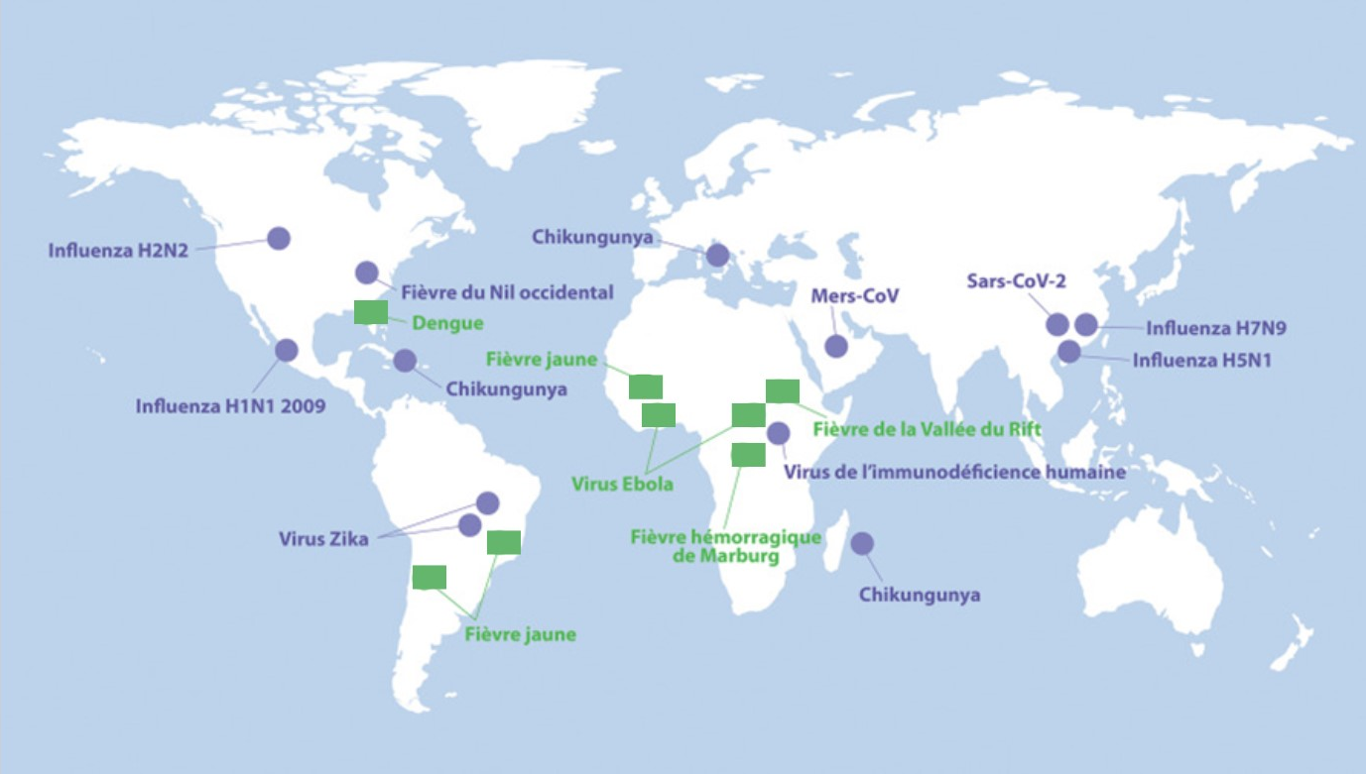

With the COVID-19 pandemic, the global threat has become a reality: in less than three years, over 757 million cases have been confirmed worldwide (WHO), with a spatio-temporal distribution made up of multiple, unpredictable twists and turns (Figure 16). In all, more than 18 million deaths attributed to COVID-19 have been reported (Figure 17), while more than 13 billion doses of vaccine have been administered.

Figure 16 - Notification of Covid-19 cases to WHO by world region (as of February 21, 2023) (26)
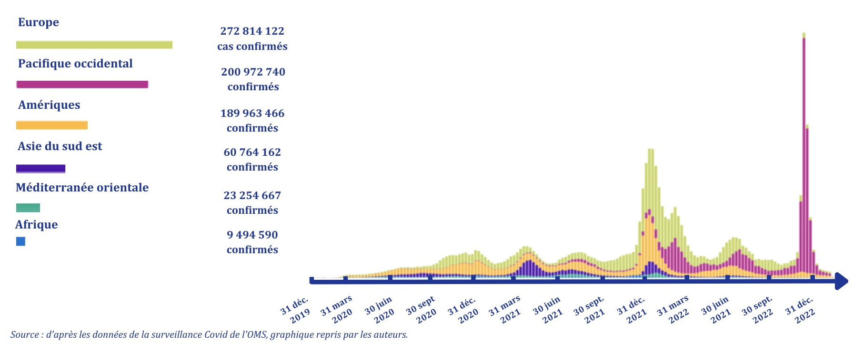

Figure 17 - Worldwide reporting of Covid-19 deaths to WHO (as of 22/02/2023)(26)
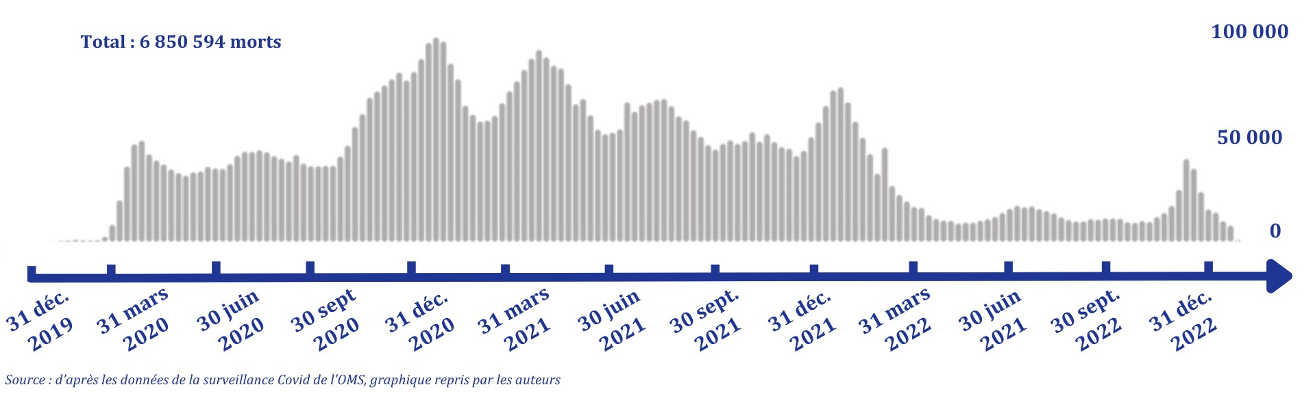
The situation is paradoxical in the USA, where the majority of vaccines have been developed and produced. In fact, the USA has the highest number of reported deaths, exceeding 1.1 million by 2023. This situation is partly explained by the prevalence of non-communicable diseases (and diabetes in particular), which have exacerbated the disease, as well as major inequalities in terms of health determinants and access to health services.

Non-communicable diseases (NCDs) on the rise worldwide

Whereas in 2000, non-communicable diseases (NCDs) accounted for just four of the 10 leading causes of death worldwide, they will account for seven of the 10 leading causes of death in 2020, with NCD-related mortality increasing by around 30% over these two decades. Today, NCDs account for around 41 million deaths a year. The four main causes of NCD-related deaths are cardiovascular disease (17.9 million per year), cancer (9.3 million), chronic respiratory disease (4.1 million) and diabetes (2 million).
NCDs are the main cause of death in high-income countries, with the number of deaths decreasing with income level. Communicable, maternal, perinatal and nutritional diseases are still the leading cause of death in low-income countries (Figure 18).
Figure 18 - Distribution of causes of death (in %) worldwide, by country groups according to income level, 2019 (27)
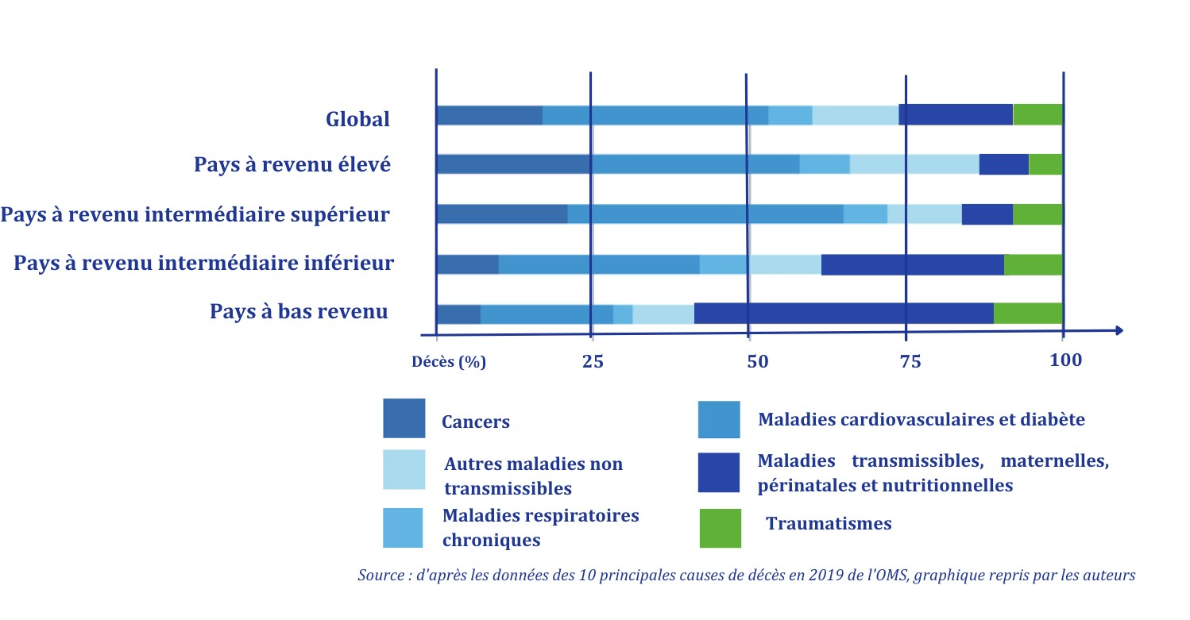

In this section, we elaborate on some of the non-communicable diseases that we consider particularly important.

Cardiovascular disease: the world's leading cause of death

Cardiovascular disease is the world's leading cause of death, accounting for around 18 million deaths a year. More than 4 out of 5 deaths from cardiovascular disease are linked to heart attacks and strokes, and a third of these deaths occur prematurely in people under 70. Three quarters of these deaths occur in low- and middle-income countries, where people have less access to early detection and treatment programs for people at risk than people in high-income countries.

Diabetes: a meteoric rise in mortality

Among NCDs, the evolution of diabetes prevalence over the last twenty years is particularly worrying, having more than tripled between 2000 and 2021, from 151 million to 537 million people aged 20-79. The Lancet estimates that between 6.1-9.8% of the world's population is affected by the disease. Diabetes kills around two million people every year (International Diabetes Federation), 96% of whom suffer from type 2 diabetes. The causes of this disease are complex, but most of the burden is attributable to social, dietary, environmental and occupational risk factors, alcohol consumption and lack of physical activity, resulting in increased body mass index in individuals (28).
The prevalence of the disease is rising particularly sharply in the Western Pacific (driven in particular by China) and South-East Asia regions, which together will account for 55% of diabetes cases in 2021 (Figure 19). The situation is also worrying in the Middle East and North Africa, where prevalence has risen from 7.7% to 18.1% in two decades, while the African continent is relatively unscathed for the time being, accounting for just 4% of diabetes cases worldwide, due to lower levels of urbanization, malnutrition and lower rates of overweight and obesity.

Figure 19 - People living with diabetes worldwide, by region, 2000-2021 (29)
Populations in low- and middle-income countries are increasingly affected, due to the dietary transition towards ultra-processed products and their lack of means to treat overweight. The extent of the disease is globally underestimated, both politically and financially, with glaring inequalities in access to appropriate treatments.

Cancers: increasingly diverse risk factors and populations

Today, cancer is one of the world's leading causes of death, accounting for six million deaths in 2000 and almost 10 million deaths in 2020 (i.e. almost one in six deaths). In women, the most common and lethal cancers are breast, lung, colorectal and cervical, while in men they are lung, prostate, colorectal, stomach and liver (Figure 20).

Figure 20 - Estimated cancer mortality and incidence rates for men and women worldwide in 2020 (27)
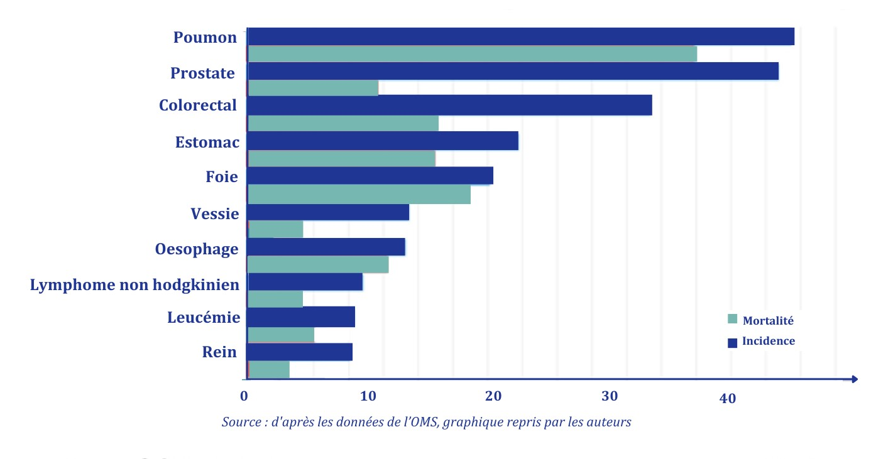
According to two reports by the WHO and the International Agency for Research on Cancer (IARC) published in February 2020, 18 million cancers were diagnosed in 2018, a 20% increase on 2012 (30)while the Foundation for Medical Research reported in 2015 a 30% increase in the number of cases since 2005 (31). This increase is closely linked to the world's ageing population and population growth.
The causes of cancer differ from one region of the world to another. According to the WHO, the main universal and modifiable determinants of cancer are smoking, alcohol consumption, poor diet and a sedentary lifestyle. Other cancer risk factors, notably breast, bladder and lung cancer (32) are now clearly identified as being linked to the living environment, and in particular to exposure to pollution. The WHO estimates that 19% of cancers - almost one in five new cases - are linked to environmental factors. Over the past few decades, population growth, urbanization, industrialization and the intensification of road transport in so-called emerging countries have all contributed to a deterioration in the quality of the air we breathe. In Africa, part of the increase in lung cancer cases is attributed to the oil industry and exposure to heavy metals (33). In 2022, a report by the European Agency for Development estimated that in Europe - home to less than 10% of the world's population, and where 23% of cancer cases are recorded (34) - 10% of cancers were due to exposure to toxic substances (air pollution, radon, ultraviolet radiation, environmental tobacco smoke and chemicals) in the home, including the workplace. In France, lung cancer deaths attributable to fine particulate matter rose by 29.3% between 1990 and 2017 (35). Environmental determinants are therefore part of the list of modifiable determinants found in all regions of the world. Their prevalence is likely to vary over time, depending on populations and public prevention policies. Finally, there is a strong link between the burden of communicable diseases described in the previous section and cancer. In low- and middle-income countries, three out of ten cancers are attributable to infections with viral hepatitis viruses or human papillomaviruses (HPV), against which there are highly effective and accessible means of prevention (hepatitis B and HPV vaccines) or treatment (hepatitis C).
Inequalities between regions of the world, and social inequalities within countries, are obvious when it comes to access to and use of cancer screening and early diagnosis resources. This creates a real gap in access to anti-cancer treatments. An international survey conducted in 2019 estimated that cancer patients could benefit from comprehensive treatment in over 90% of high-income countries, compared with less than 15% of low-income countries. The theme and slogan of World Cancer Day 2023 was "For fairer care", indicating the recent awareness of this issue (36).
The WHO has published a global action plan common to four of the five NCDs (excluding mental health). The EU has developed a plan and is investing in a coordinated way in this public health priority.

Mental health: diseases that are still largely neglected

The overall prevalence of mental health problems has remained stable (around 13%) over the last twenty years (around 1 in 8 people) but has increased by a quarter in absolute terms due to population growth, with 970 million people affected in 2019, before the effects of the COVID-19 pandemic worsened the situation (37). Significant geographical inequalities are observed in terms of care. Over 75% of people with mental disorders living in low- and middle-income countries receive no treatment at all. More generally, there has been very little change in the way mental health care is conceived in most parts of the world, making mental health problems a very punishing part of people's lives. Several factors prevent people living with mental health problems from seeking help: poor quality of services, lack of knowledge about mental health, stigmatization and discrimination.
Today, an estimated 280 million people worldwide suffer from depression, or 5% of adults (4% of men and 6% of women). Suicide remains one of the main causes of death, with 700,000 people committing suicide in 2019, or 1 in every 100 deaths. However, the trend is rather positive, since between 2000 and 2019, the global suicide rate fell by 36%, with strong regional disparities. It fell by 17% in the Eastern Mediterranean region, 47% in Europe and 49% in the Western Pacific, while it rose by 17% on the American continent. Worldwide, men are twice as affected as women, and suicide is the fourth leading cause of death among young people aged 15 to 29.
Some mental health indicators are particularly worrying, even if they are currently limited to certain countries. A very significant example is the near-exponential curve of overdose deaths in the United States, where the number of cases has increased fivefold in just over twenty years, topping 106,000 deaths in the midst of the COVID-19 epidemic in 2021, and exploding particularly among men (Figure 21).

Figure 21 - Deaths attributed to overdoses, overall and by gender in the United States, 1999-2021 (38) 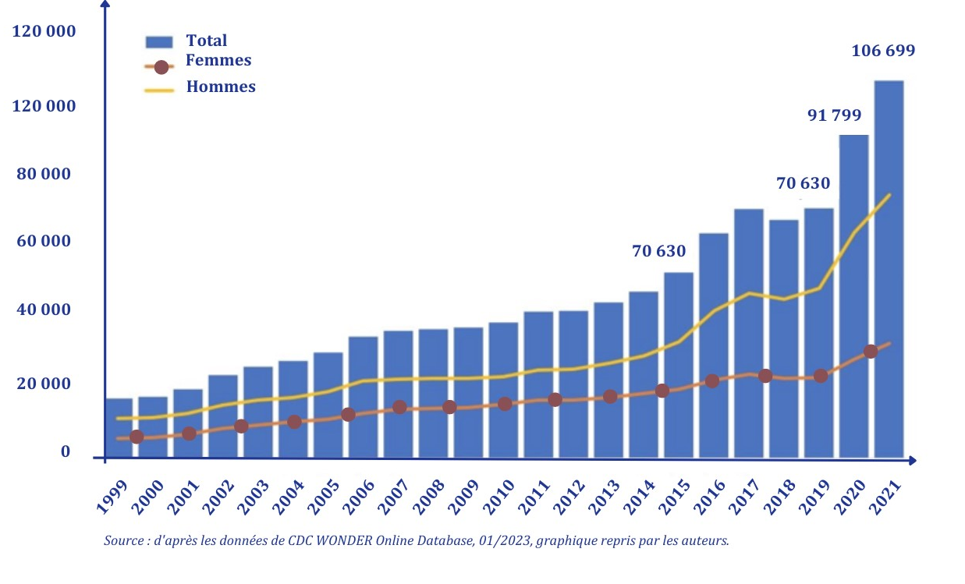

The need to invest today in the prevention and management of non-communicable diseases

Recognition of NCDs as a global health issue is relatively recent, since the first session of the United Nations General Assembly devoted to the subject was held in 2011. One out of every two NCDs is preventable, being linked to three groups of factors on which it is possible to intervene: behavioral factors (smoking, unbalanced diets, excessive alcohol consumption, sedentary lifestyle), environmental factors (air pollution) and biological factors (excessive and uncontrolled blood pressure, overweight and obesity, hyperglycemia, hypercholesterolemia).
NCDs are now at the heart of sustainable development issues. There is international consensus that, on the one hand, NCDs are driving health costs up and will continue to do so in most parts of the world, and that, on the other, they have major indirect economic consequences, notably by reducing adults' capacity to work and thus productivity. Investment in the prevention and management of NCDs appears to be highly profitable from both an individual and societal point of view, both nationally and internationally. SDG target 3.4 aims to reduce premature deaths due to NCDs by one-third by 2030. However, in the absence of an international political commitment, it is unlikely that significant results will be achieved outside a handful of countries according to WHO estimates in 2022 (13).

Global health under pressure from climate and environmental crisis

Three major interdependent problems are threatening the environment today: climate change, pollution and biodiversity loss. This is the "triple environmental crisis" or "triple planetary crisis". Each of these problems has its own causes and effects, and must be resolved if we are to have a viable future on earth.
The Intergovernmental Panel on Climate Change (IPCC) has unequivocally established that climate change is a threat to human well-being and the health of the planet (information benefiting from the IPCC's highest level of confidence).(39). Climate change has a direct and indirect impact on health, according to a complex causal chain that takes account of exposure pathways and vulnerability factors, described by a diagram published by the WHO in its special report on climate and health published for COP 26:

  - Figure 22 (40) Human health and the interconnections between climate risks, exposure pathways and vulnerability factors
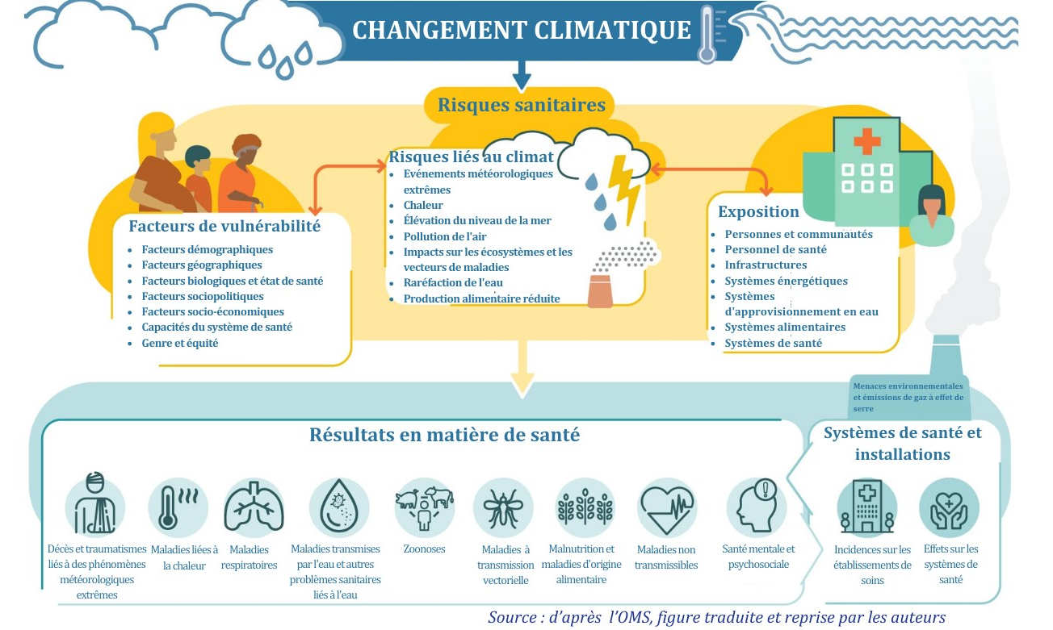

It should be noted that climate change increases the pressure on health systems through rising health-related needs: increased morbidity and prevalence of climate-sensitive diseases, higher healthcare costs and difficulties in accessing services. Increased use of health services can also generate higher carbon emissions, as health services themselves have a significant climate footprint, equivalent to around 5% of global greenhouse gas emissions (41) due to the production and transport of materials, energy consumption and waste treatment. If the health sector were a country, it would be the fifth largest emitter on the planet. The three biggest emitters, the United States, China and the countries of the European Union, account for more than half the global carbon footprint of the health sector (56%)(42).

The impact of the climate and environmental crisis on health and its determinants

The burden of human disease caused by climate change on a global scale is still difficult to assess accurately, but there are many factors that should alert us, including the rise in the number of heat-related deaths, changes in the distribution of water-borne diseases (such as cholera, dysentery, hepatitis A and poliomyelitis), an increase in the ecological niches of certain infectious disease vectors, the overall disruption of livelihoods (meaning all the physical, social and financial resources and capacities needed to satisfy basic needs), worsening food insecurity, and the depletion of water resources and their declining quality in arid subtropical regions. According to the latest Lancet Countdown report (40) published in November 2023, the number of heat-related deaths could increase fivefold by 2050, mainly in the world's poorest and already hottest regions.
Exacerbating existing health problems, global warming is likely to have an increasingly strong influence on health worldwide in the years ahead, and none of the major determinants of health will be spared. In particular, increased pressure on water resources, already stretched by overexploitation and degradation, will lead to greater demand in the future. Changes in average temperatures and rainfall and their variability will lead to variations in the incidence and geographical spread of vector-borne and water-borne diseases.
Between 2030 and 2050, the WHO expects climate change to result in almost 250,000 additional deaths per year, due to malnutrition, malaria, diarrhea and heat-related stress . This type of projection remains fragile, however, due to the complexity of the factors driving change and the constant revision of assumptions. However, it seems clear that climate change is already exposing millions of people to high-risk flooding (Map 2).

  - Map 2 - Worldwide floods by type and total exposed population (44)

South Asia thus has a very high concentration of people exposed to flooding. The total population residing in places where floods have been observed by satellite increased from 58 to 86 million people between 2000 and 2015. This represents a 20% to 24% increase in the proportion of the world's population exposed to flooding, ten times higher than 2010 estimates (45).
Since 2008, an average of 22.5 million people a year have been forcibly displaced by sudden-onset weather events - such as floods, storms, forest fires and extreme temperatures. In 2022 alone, 8.7 million people in 88 countries were forcibly displaced by natural disasters, 45% more than in 2021 (Map 3).

  - Map 3 - Number of people displaced within their own country by natural disasters in 2022 (46)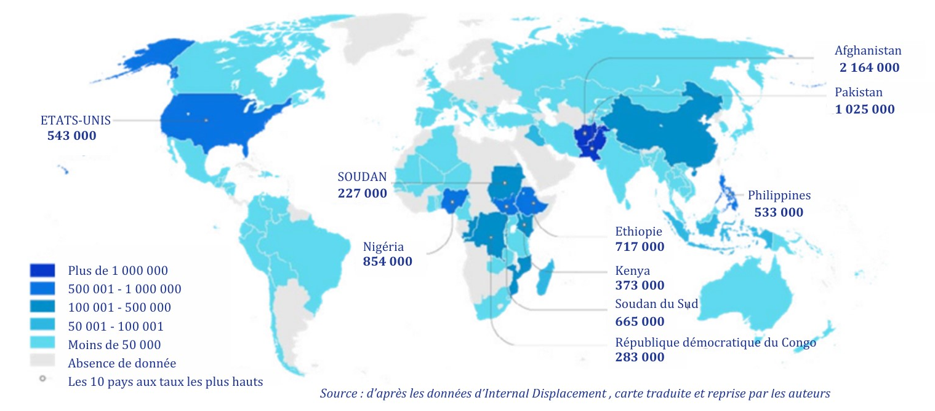
But population displacement cannot be exclusively attributed to or associated with natural disasters. The growing impact of humanitarian crises and conflicts on the health of populations, particularly in countries considered to be fragile states, must also be taken into account in order to obtain a more accurate picture of population displacement. (47).
On the environmental front, the degree of exposure to toxic agents and their impact are the subject of much research. The second edition of the Lancet Planetary Health report published in 2017 estimated that 16% of non-communicable diseases and premature deaths are attributable to exposure to toxic air, water, or soil, causing the deaths of nine million people each year. The WHO estimates that 91% of the world's population lives in places where air pollution levels exceed the limits set by its 2022 guidelines. This is particularly the case in China, where pollution levels have risen sharply over the past two decades and now exceed the thresholds set by the WHO. (35). According to a WHO study conducted between 2008 and 2015, Southeast Asia and the Eastern Mediterranean exceeded WHO limits by between five and 10 times (48). For example, 74mg of fine particles per m³ of air were observed in Bangladesh, for an upper limit set at 5mg.
Finally, certain recently identified factors, such as endocrine disruptors, are contributing to the increase in chronic diseases (49).

Zoonoses, a marker of the link between human, animal and environmental health

According to the WHO definition, "a zoonosis is an infectious disease that has been transmitted from animals to humans. Zoonotic pathogens may be of bacterial, viral or parasitic origin, or may involve non-conventional agents and spread to humans through direct contact or via food, water or the environment" (50). Examples include coronaviruses, avian and swine influenza, salmonellosis and rabies. The impact of environmental changes on zoonoses, particularly those linked to the destruction of animals' natural habitats and their closer proximity to humans, is relatively poorly documented over the period 2000-2010, but some important developments can be noted:
- Deforestation has intensified since 1990, with the loss of more than 420 million hectares of forest worldwide, over 90% of which is in tropical zones. (51). In addition to its effects on biodiversity, this deforestation contributes to the destruction of natural habitats for wild animals, and increases the proximity between humans and animals, facilitating the transmission of zoonoses.
- Rising temperatures are another factor in the multiplication of zoonoses. For example, it is likely to lead to a global expansion in the distribution of Aedes aegypti and Aedes albopictus mosquitoes, the main vectors of dengue fever, yellow fever, chikungunya and Zika. On a global scale, the population exposed to disease transmission by one of these vectors is therefore set to increase significantly, and this growth is likely to be intensified by other factors such as urbanization (52).

Progress towards Universal Health Coverage has stagnated or even regressed since 2015

Universal Health Coverage (UHC) is defined as "access for the entire population to the quality promotional, preventive, curative and palliative health services they need, without financial hardship for users" (WHO 2010).

  - Box 4: Universal health coverage
Achieving universal health coverage involves :
- Equitable access to health services, which means removing the financial, social, geographical and legal barriers to access for all, including the most vulnerable populations,
- Coverage by quality health services, and
- Financial protection that minimizes financial hardship due to households paying for health care.
UHC is often represented by a cube that needs to be enlarged in all its dimensions: as many people as possible must be covered (horizontal axis), individual cost-sharing must be reduced (vertical axis), and access to health service packages must be as broad as possible, including sexual and reproductive health as well as health promotion and prevention services (axis perpendicular to the first two).

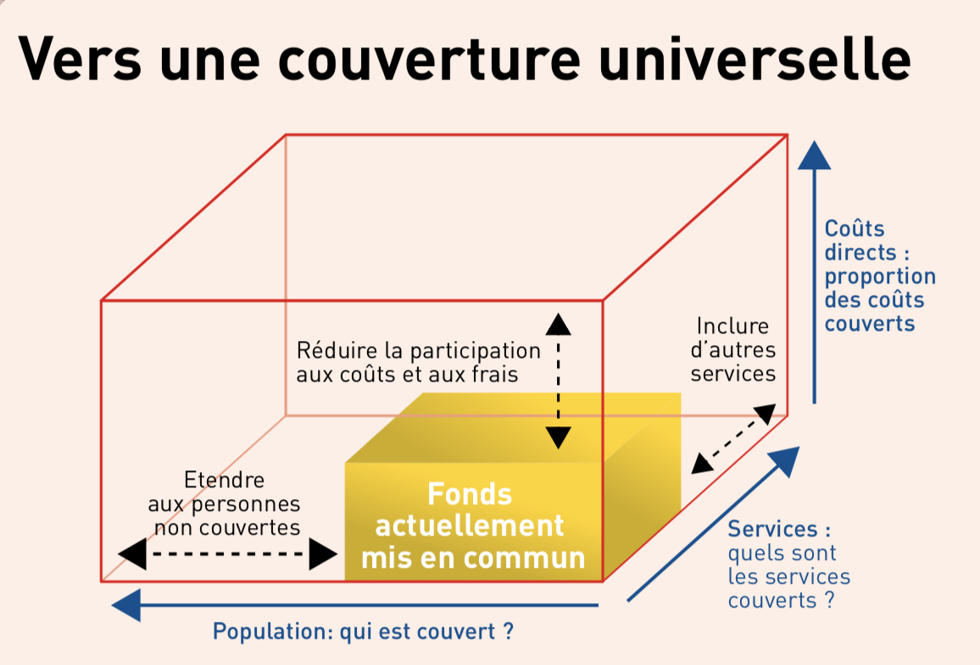

Achieving universal health coverage is one of the Sustainable Development Goals (Objective 3.8). Progress towards universal health coverage is measured by two indicators: health service coverage (SDG 3.8.1) and financial protection (SDG 3.8.2).

Progress in health services coverage stalled at a plateau

Figure 23: Evolution of the global Universal Health Coverage index, 2000-2021 (53) 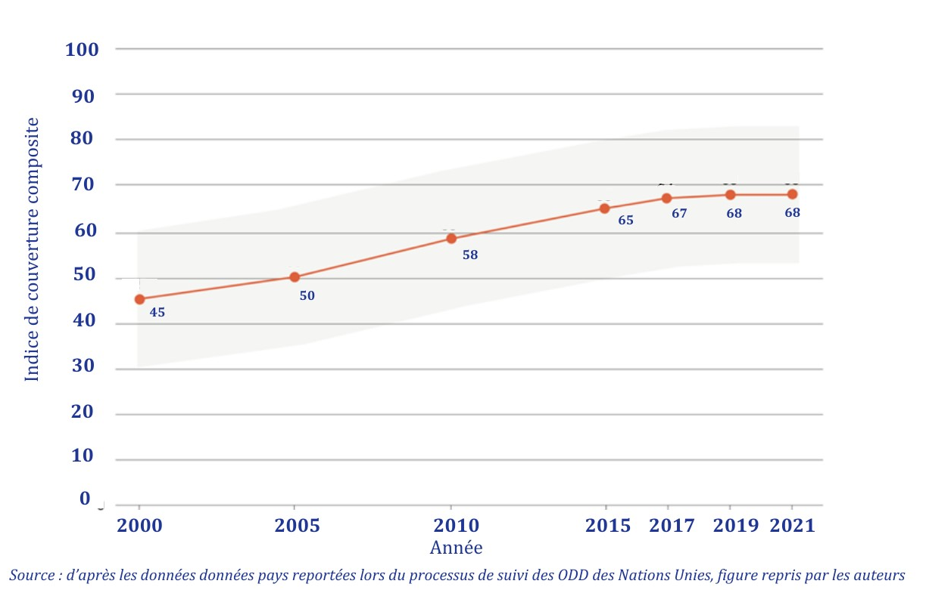

Health service coverage rose sharply in the first two decades of the 21st century. Health service coverage (SDG 3.8.1) is measured by a composite index, the Service Coverage Index (SCI) . According to WHO and the World Bank (54) the global SCI has risen from 45 in 2000 to 68 in 2021, demonstrating a positive global dynamic. In 2000, 68 countries had service coverage levels considered low or very low (SCI <40), compared with 14 countries in 2021. Health service coverage rose sharply between 2000 and 2017, then stabilized. Recent progress has thus been slower than that prior to 2015, with the SCI increasing by just three index points between 2015 and 2021, suggesting that health service coverage has reached a plateau globally.
The proportion of the population not covered by essential health services fell by just 15 index points between 2000 and 2021, with a clear slowdown in progress after 2015. In fact, more than half of the world's population (around four and a half billion people) is still not covered in terms of access to the most essential health services, particularly in rural areas or among the poorest households in different countries, including high-income countries. In the USA, for example, African-American women are three times more likely to die from pregnancy-related causes than women who identify themselves as "Caucasian", due to their poorer access to prenatal and delivery services. (55).

map 4 - gains in health service coverage, 2000 to 2021, in percentage terms (54)

The composite index includes sub-indices covering four key health areas: 1) reproductive, maternal sexual, neonatal and child health, 2) infectious diseases, 3) non-communicable diseases, and 4) health service capacity. The biggest gains in health service coverage happened in Asia. Coverage has also increased in Africa, where initial coverage was particularly low in 2000. Values for indicators relating to non-communicable diseases, maternal, neonatal and child health, as well as access to health services or health system capacity, increased only measurably and progressively before 2015, with minimal or no improvements from 2015 to 2020 (54).
Improvements in the health services coverage index between 2000 and 2021 are therefore mainly (around 60%) attributable to interventions dedicated to infectious diseases, and in particular to antiretroviral treatment for people living with HIV (54). While very significant gains were observed at the start of the period, marked by the new worldwide availability of Highly Active Antiretroviral Therapy (HAART), and in particular for the African continent, where two-thirds of the HIV/AIDS epidemic is concentrated, the "catch-up" effect has now taken place, and is unlikely to be repeated, to the same extent, in the years to come. The dynamics of the upward curve in service coverage are therefore essentially linked to the dynamics of access to HIV treatment. In the future, a different dynamic will be needed to increase access to a wide range of health services.
Despite this positive momentum of progress on the front of the HIV/AIDS pandemic and childhood infectious diseases, health service coverage thus remains low in the poorest countries, with prospects for increase relatively limited today without greater investment in expanding health systems and improving service access strategies for the poorest groups.
With regard to access and capacity of health systems in particular, the sub-index has been very high and stable in high-income countries (between 95 and 96) since 2000. The poorest countries have made little progress over the past 20 years. Aid-dependent countries have thus developed their health systems less than middle-income countries with greater domestic resources.
Moreover, inequalities in access to services persist even within countries and societies. At all income levels and for most services, the poorest use health services less than the richest. Coverage of reproductive, maternal and child health services is lower in the poorest households than in the richest. Child immunization, in particular, remains highly unequal, even though it is heavily subsidized by development aid. (Figure 24)

Figure 24 (56) Disparities in access to essential health services, by country and according to wealth level

Financial protection for populations worsening

The second objective of Universal Health Coverage is to ensure that all individuals have access to health services without incurring financial hardship. Universal health coverage is therefore also defined through a second dimension: financial protection against the risk of "catastrophic expenditure " and impoverishing expenditure. In fact, the proportion of the population facing catastrophic levels of out-of-pocket health-related expenditure increased over the first two decades of the 21st century, leading to a setback in progress towards universal health coverage. Economic growth and falling poverty have increased demand for health services, financed by rising household contributions to these expenses. With the financial difficulties associated with these contributions, financial protection has generally deteriorated over time. In the face of these difficulties, public policies have adapted more slowly than market dynamics, and have been slow to put in place mechanisms for the collective assumption of health risk in line with household demand.

Box 5: Affordability of health services
- From 2000 to 2019, the global incidence of catastrophic health-related expenditure () has risen steadily, from 9.6% of the world's population in 2000 to 12.6% in 2015, and 13.5% in 2019.
- The proportion of the world's population impoverished or further impoverished at the level of the extreme poverty line (USD 2.15 per day per person in 2017 purchasing power parity) by out-of-pocket health expenditure fell from 22.2% in 2000 to 15.6% in 2015 and 4.4% in 2019. However, at the same time, the proportion of the world's population impoverished or even more impoverished at the relative poverty line (60% of a country's median per capita consumption) by household health-related expenditure has increased, from 11.8% in 2000 to 15.6% in 2015 and 16.7% in 2019.
- Between 1.3 and 2 billion people worldwide experienced financial hardship in 2019, with 1 billion facing catastrophic health expenses and 344 million facing impoverishing health expenses at the extreme poverty line (almost half of the world's population living in extreme poverty in 2019).
- Data from 29 low- and lower-middle-income countries show that, prior to the pandemic, financial reasons accounted for 18.5% of care refusals.
Source: WHO-World Bank, 2022.

The number of people incurring catastrophic health costs has risen steadily worldwide since 2000, and will exceed one billion in 2019 (57). The proportion of households devoting more than 25% of their budget to cash health expenditure rose from 1.9% in 2000 to 3.3% in 2015 and 3.8% in 2019, an average annual increase of 0.1 percentage points. The COVID-19 crisis has further contributed to a worsening of catastrophic and impoverishing health-related spending and an increase in care foregone due to financial barriers . The proportion of households facing catastrophic expenditure has increased over the last two decades.

Figure 25: Incidence of catastrophic health expenditure - Proportion of the world's population with over-the-counter health expenditure exceeding 10% or 25% of the household budget (2000-2019).
At the same time, the number of countries with social health insurance (SHI) has increased since 2000, reaching 126 countries in 2017 (out of 195 countries in all), 13 more than in 2000. Generally speaking, however, there is little scientific evidence on the specific benefits linked to the introduction of social insurance mechanisms in the construction of UHC (58). On the other hand, the role of public funding, either directly or through social insurance schemes, appears to be essential, and has been shown to protect against economic shocks linked to household health expenditure. (59). No country has ever achieved universal health coverage without a significant level of public subsidy to ensure access for the poorest and protection against financial difficulties linked to the risk of illness.

As we enter the third decade of the 21st century, the founding principles of universal health coverage are well recognized: i) inclusion of promotional, preventive, curative and palliative services ii) importance of quality iii) inclusion and equity and iv) financial protection. However, progress towards the 2030 targets is far from sufficient and has slowed sharply since 2015. More than half of the world's population, the poorest and most vulnerable, have no access to quality health services. Economically disadvantaged populations have less access to health services in all countries regardless of their level of economic development. Service coverage remains largely inequitable, with the poorest groups still excluded from access to the most essential health services, and the quality of services remains low (more than half of premature deaths in developing countries are linked to low-quality services)(60)) The proportion of households experiencing financial difficulties is also on the rise. This slowdown in progress contrasts with the improvement in health indicators for infant mortality, driven by economic growth and the fall in poverty. The UHC agenda requires a new impetus and most countries, especially the poorest ones, need to design new strategic directions and roadmaps, if progress in access to health services is to be restored.

Health funding has increased steadily over the past twenty years, but is very unevenly distributed

While the pace of growth slowed down after the economic crises of 2008-2009, global health spending increased over these two decades, reaching a peak of $9,210 billion (9.21 trillion), or 10.3% of global GDP in 2021, with very significant differences depending on countries' income levels (61). The overall volume of health spending is being driven upwards by OECD countries and emerging countries such as China, India and Brazil (62). Spending of American and European countries represent three quarters of global health-related spending in The overall volume of health spending is being driven upwards by OECD countries and emerging countries such as China, India and Brazil (62). Health spending remains comparatively low in low-income countries, increasing only modestly over the past 20 years. Globally, in 2019, the African continent accounted for 16% of the population but only 1% of health spending (63).

Figure 26 - Health spending in Africa: a greater role for the private sector and development aid

Sources of health funding vary greatly according to countries' income levels. Globally, two-thirds of health expenditure comes from governments (63%), followed by households (36%), while health-related aid accounted for just 0.2% of total health expenditure in 2018. In Africa, private financing by households is more important (57%), and foreign aid amounts to 10% of total health spending (61). These amounts are particularly significant for the 20 poorest countries that depend on them. But in low-income countries, in 2020, direct household payments accounted for the largest share of health expenditure, ahead of domestic public spending and international aid. Aid accounts for an average of 25% of health expenditure in these countries.

Figure 27 - Trends in health expenditure, 2000 to 2020, by country income level (64)
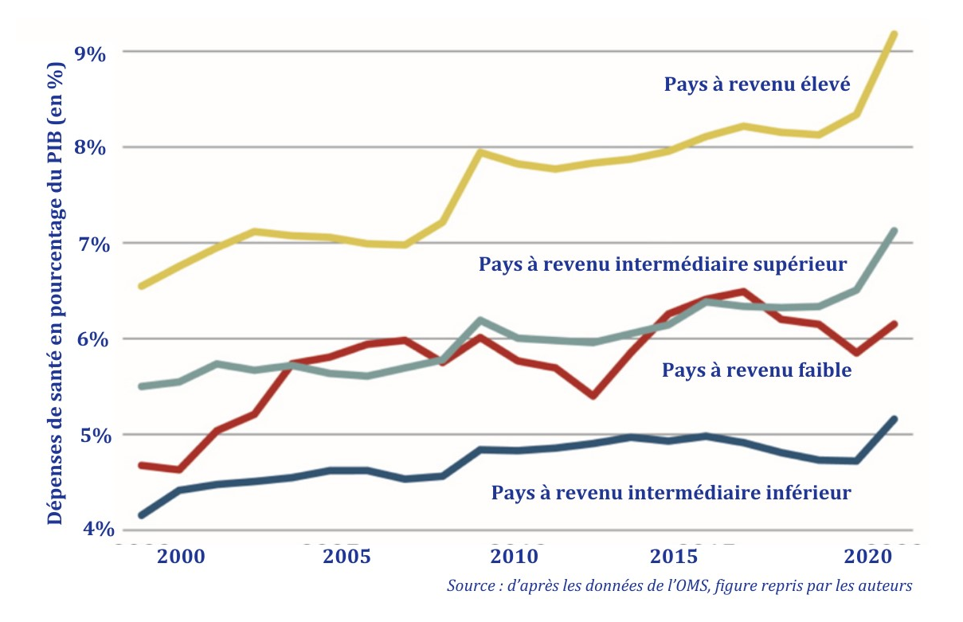
Figure 28 - Public spending on health per capita and as a percentage of GDP in low-income countries, 2018 (43)

In 2018, in almost two-thirds of the 32 low-income countries, public spending on health was less than US$10 per capita per year (Figure 28). Not only is this level of public spending very low, but more importantly, the priority given to health spending by governments in low-income countries is decreasing, over the period, whereas it is increasing in high-income countries (highlighted in yellow in Figure 29).

Figure 29 - Share of public spending on health, by country group, 2000 - 2018 (64)
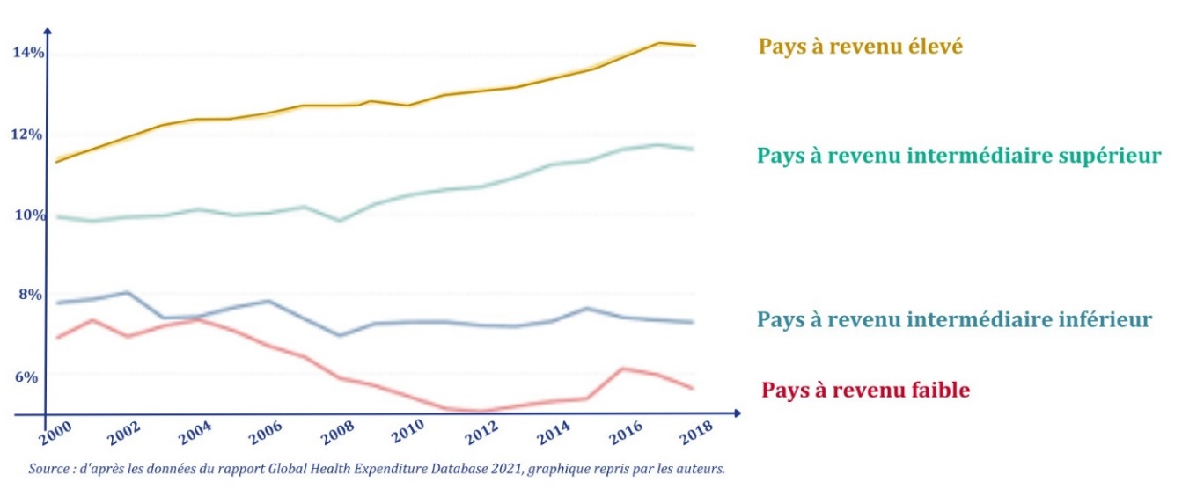
While overall volumes have risen, the percentage of public spending devoted to health is clearly declining over the period in low-income countries. This decline in the importance attached to health issues by public authorities in their national budgets may be linked to a substitution effect. In fact, the share of foreign aid allocated to the health sector has increased (64) over the same period.

Figure 30 - Foreign aid and public spending on health in low-income countries (64)

At a global level, and in response to the imbalance between needs and funding for health-related aid, the countries of the African Union made a commitment in 2001 to allocate at least 15% of their national budgets to public health (Abuja Declaration). By 2019, only three countries had met this commitment: Ethiopia, Guinea and Malawi (63).
In high-income countries, public spending accounted for at least 65% of total health expenditure between 2000 and 2019, which explains the overall trend in public spending worldwide. In middle-income countries, over the period studied, there was a decline in the share of household payments, both in the top bracket (from 39% to 31%) and in the bottom bracket (from 44% to 38%). In the upper bracket, this reduction in private spending is essentially due to the increase in public domestic spending, while in the lower bracket, it is linked in particular to the increase in development aid, which almost doubled over the period.

While the first decade of the 21st century saw exceptional international mobilization in health-related aid (with an average annual increase of 10% between 2000 and 2010), the volume of international funding has stagnated since the financial crisis of 2013 (Figure 31).

Figure 31 - Sources of health-related aid funding, (2021 and 2022 are commitments) 1990-2022 (65)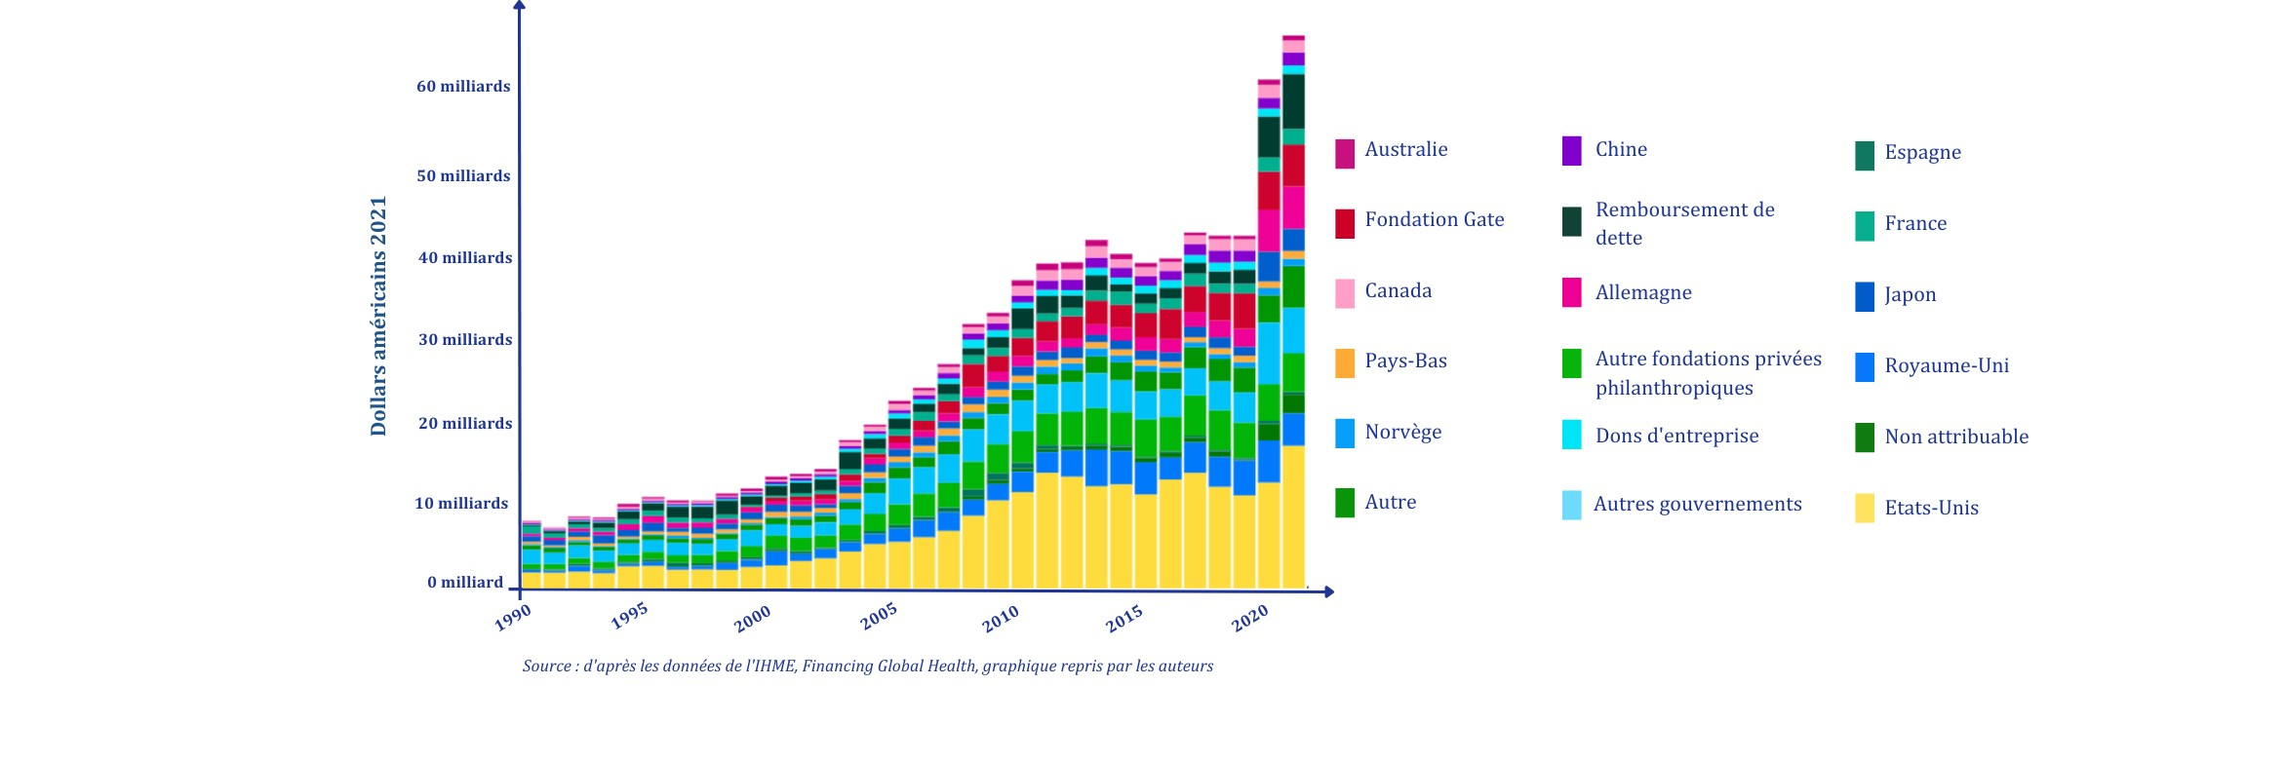
US funding (USAID, PEPFAR in particular) accounts for an average of 40% of total annual funding for health-related aid over the period. Philanthropic players, and in particular the Bill and Melinda Gates Foundation also play a major role, being the second-largest funder of health-related aid after the United States in 2019, accounting for more than 10% of total aid.
Overall, over the two decades, most health-related aid has gone to middle-income countries. This is also true for French aid development funding, despite a list of priority ODA countries that until 2023 exclusively included low-income countries. Countries such as Egypt, Lebanon and Côte d'Ivoire were among the top 10 recipients of French health-related aid in 2020 (66).

Figure 32 - Trends in health-related aid by income level of recipient countries, 2000-2020 (65)
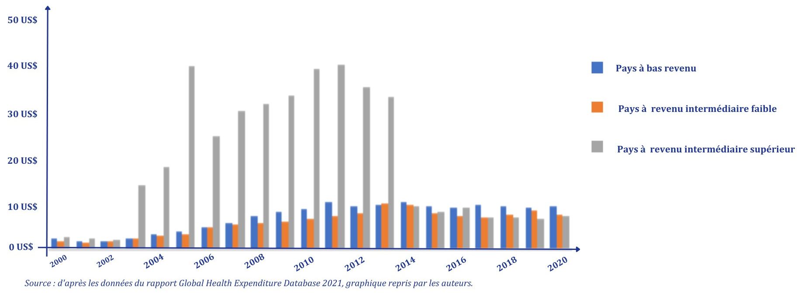
This priority allocation of health-related aid to middle-income countries can be explained by the priority given to the fight against HIV/AIDS, particularly in southern Africa, until 2013. While health-related aid has been more evenly distributed between low- and middle-income countries since 2013 (the time of the global economic crisis), its overall volume has stagnated since then.

Figure 33 - breakdown of government, household and international aid spending on health in low- and middle-income countries in 2019 (65)
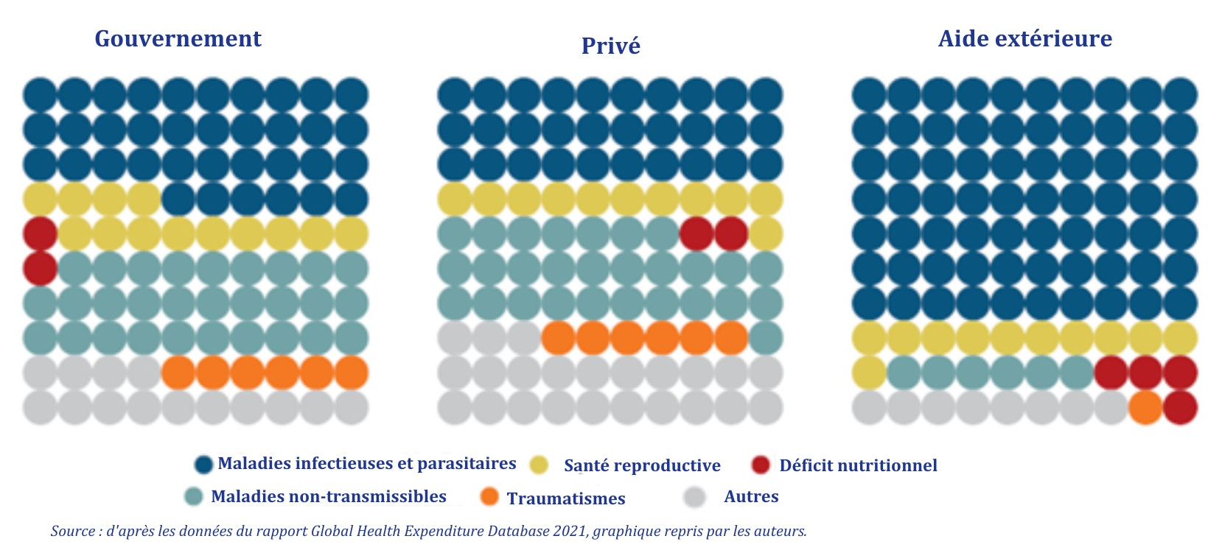

In fact, over the entire period, more than a third of government spending, a third of household spending and more than two-thirds of health aid were dedicated to combating infectious diseases in low- and middle-income countries, leaving little room for strengthening health systems, which accounted for just 12% of aid funding allocated over the two decades. (65).
Global health funding has therefore increased significantly over the last 20 years, and now accounts for over 10% of global GDP. In an increasingly globalized world economy, global health spending is mainly driven upwards by public funding in OECD countries, but also increasingly in emerging countries. Health financing in the poorest countries, on the other hand, is dominated by private funding from households, whose demand for health care has risen rapidly over recent decades, in line with economic growth (rising household incomes) and falling poverty. Public spending on health, on the other hand, has evolved more slowly than economic growth, confirming the difficulties faced by the poorest countries in setting up public financing institutions for universal health coverage. Development aid for health represents a very small proportion of health expenditure worldwide. It is mainly concentrated in sub-Saharan Africa. This aid, which is programmatic and focused on the financing of health products, has largely benefited the countries of Southern Africa in response to the AIDS epidemic in this region. But very little of this funding has been invested in strengthening health systems. Health aid has also contributed to the crowding-out of public spending on health in the poorest countries (67) In Bangladesh, an additional dollar of development aid displaced about the same amount of public health spending (68,69). This weakness in health financing systems was highlighted by the COVID-19 crisis. To return to a positive trajectory towards UHC, reinvestment will be needed in building national health financing institutions and mobilizing domestic public resources. This will call for better use of public subsidies, in particular fossil fuel subsidies, which currently account for $6,000 billion (US$6 trillion) a year, equivalent to the total public spending on health globally. Many countries are also engaged in a public policy dialogue on new tax incentive mechanisms for health (tobacco, alcohol, sugar, salt, in particular) and the environment (air pollution, methane tax, for example).

Access to health products is still inadequate, despite historic advances

Access to safe, effective, high-quality and affordable medicines and health products is a prerequisite for progress towards universal health coverage. Health products must be specifically regulated and made more accessible, so that innovations can benefit as many people as possible.
The period 2000-2019 was marked by considerable progress in terms of access to medicines, vaccines and diagnostics, thanks in particular to the mobilization of players in the fight against AIDS . The November 2001 Doha Declaration on Trade-Related Aspects of Intellectual Property Rights (TRIPS) was a major turning point, authorizing a country to grant "compulsory licenses" allowing foreign medicines to be "copied" for domestic use in the event of a national health emergency, stressing that the agreement "does not and should not prevent member governments from taking action to protect public health". (70) ". ". A waiver to patent law recognized by the WTO on August 30, 2003 implements Article 6 of the Doha Declaration and authorizes generic drug-producing countries such as India, Canada and Brazil to sell generics of patented products to countries unable to manufacture them themselves. In fact, over these two decades, the price of ARV treatment has fallen from $10,000 to treat one person for a year in 2000 to less than $100 a year today. Other major successes in the 2000-2020 period include access to artemisinin-based combination therapies (ACTs) for malaria (2008), lower prices for pneumococcal conjugate vaccine (2010) and hepatitis C drugs (2013), and the launch of fexinidazole, an oral treatment for sleeping sickness (2018). These twenty years have also seen the creation of several initiatives dedicated to access to health products, such as the Drugs for Neglected Diseases Initiative (DNDI) in 2003 and the Medicines Patent Pool (MPP) in 2010, the latter largely supported financially by Unitaid .
The TRIPS agreements of the World Trade Organization (WTO) provide for derogations from intellectual property law to enable countries to facilitate access to health products deemed necessary for the health of their population. However, the flexibilities provided for in these agreements are rarely implemented for various reasons, such as political pressure exerted by pharmaceutical companies on governments, or insufficient technical skills in patent offices. Ensuring effective access to health products, even the latest ones, for all those who need them, is an inherent challenge for global health.
Despite this significant progress, the situation remains unsatisfactory . A third of the world's population has no access to the essential medicines they need. In the poorest regions of Africa and Asia, this figure can rise to as much as 50% of the population (71) and this inequity is not confined to access to treatments for uncommon diseases. Insulin, which has been available for over a century, is still out of reach for half the world's diabetes sufferers (72). Many health products are therefore unaffordable .
Monopolies and concentration of production limit access to vital health products and diagnostic tools in low- and middle-income countries, but also in high-income countries. The opacity of prices, pricing structures and public procurement of health products also creates major information asymmetries between public players and citizens on the one hand, and the pharmaceutical industry on the other. The health product industry's profit margins are higher than in most economic sectors, and public contributions to research and development are hardly taken into account in the price-setting process. Distorted pricing mechanisms for health products also have a major impact on the supply chain and on access to them, leading to shortages of essential medicines and other health products.
Low-income countries are not the only ones facing a crisis in access to health products. The COVID-19 crisis showed just how dependent the whole world could be on a few production lines. Since then, as the major pharmaceutical companies have abandoned cheap generic products, supply difficulties have increased, to such an extent that many voices in Africa and Europe are calling for the development of greater health sovereignty, including through the relocation of production.

Health professionals, a central issue between shortage and technological revolution

The issue of human resources for health has been on the global health agenda since the 2000s, and in particular in 2006 with the publication of the WHO report "Working together for health". (74)then in 2016 with the report of the High-Level Commission on Human Resources for Health, entitled "Committing to health and growth: investing in the health workforce" (75) both of which showed that human resources for health must be seen as the backbone of health systems and the main pillar of access to health.
Despite the calls contained in these reports for far-reaching structural reforms in the way governments train and manage their "human capital" in the health sector, an analysis of developments over the last 20 years highlights three increasingly significant challenges: the challenge of numbers, the challenge of inequalities and the challenge of training.

The challenge of the number of health professionals, largely insufficient to meet global needs, is certainly the most glaring:
- In all countries, including low-income countries, there is a growing shortage of health personnel. This was particularly evident during the COVID-19 epidemic. The shortage is particularly acute in hospital, dental and mental health services (76).
- In most low-income countries, there is a deficit of qualified health workers for the population to be covered.
- Whether in terms of trained health workers or the number of posts to be filled, training capacity needs to be drastically increased to enable better access to care.
- The World Bank estimated that there will be a global shortage of at least 15 million health professionals by 2030.
- There are many reasons for this shortage:
  - Demand is increasing with economic growth and rising private and public health spending,
  - The world's population is both constantly growing and ageing (12) including among working carers, with an increase in chronic diseases that are placing an ever-greater burden on health systems,
  - The growing participation of women in the workforce and societal changes in working patterns. Many care tasks (such as caring for the elderly or the disabled) have often and historically been performed free of charge by women, and new economic and social models are needed to meet the challenges of the social economy of dependency care.

A second challenge concerns unequal access to health personnel on a global scale.

Figure 34 - Density of certain health professionals per 10,000 people worldwide, 2014-2020 (latest available data) (77)
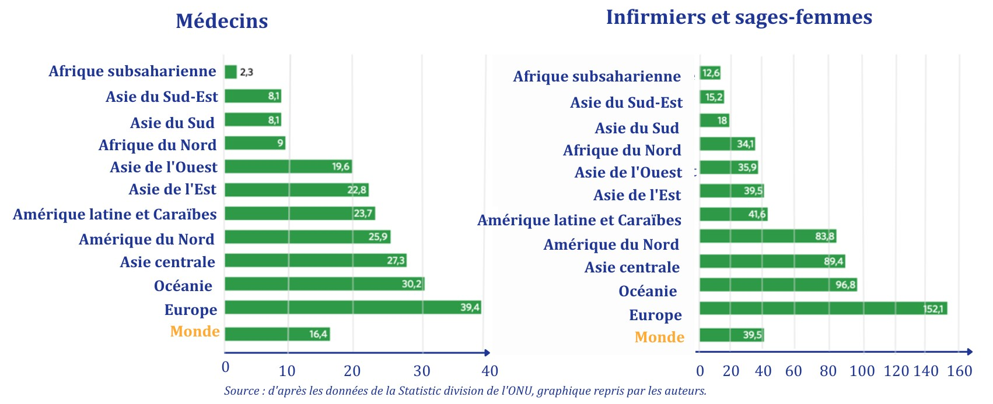

- The density of health workers varies greatly between countries. Despite a steady increase in the overall density of doctors worldwide, disparities between regions remain high. It is estimated that Europe has 39.4 doctors per 10,000 people, compared with just 2.3 in sub-Saharan Africa (78)
- The mobility of health professionals (often attributed to the "brain drain" phenomenon) raises questions about the inadequacy of training institutions for health personnel, training models, attractiveness, conditions of practice and staff incentives for health professions in low- and middle-income countries. For example, one in six doctors practicing in OECD countries obtained their degree outside the OECD area (Figure 35). In low-income countries, 84% of the population have difficulty accessing health services, mainly due to a deficit or shortage of health personnel, compared with 23% in upper-middle-income countries (79).

Figure 35 - Proportion of foreign-trained doctors and nurses in OECD countries in 2018 (47)
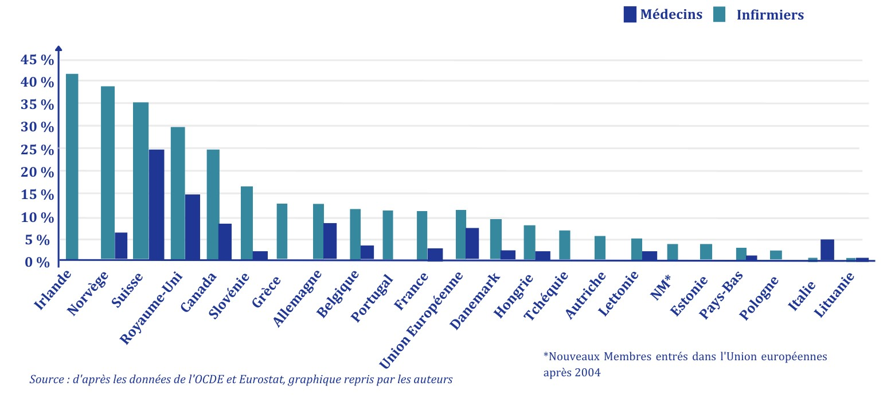
- This problem of unequal access is central to most countries, and is reflected in the growth of "medical deserts", with a concentration of health personnel in urban areas. More than half the world's population in rural areas (52%) lacks access to health due to a shortage of health professionals, compared with 24% in urban areas (77). In sub-Saharan African countries, the lack of health personnel can be considered the greatest obstacle to access to health (80)with 77% of the rural population having no access to health services due to a lack of health personnel (81).

The third challenge is that of skills and the evolution of professions in the face of new challenges. Countries' training capacities are insufficient to meet needs, in terms of both quantity and quality. Yet tomorrow's health workers will need to acquire new skills to meet new challenges:
- Health issues, with 1) the growing prevalence of multi-morbidities and the increasing burden of non-communicable diseases, linked in particular to ageing populations, 2) the emergence, persistence and/or re-emergence of infectious pathologies and 3) the impact of environmental and climatic changes, to which the One Health approach attempts to respond, integrating the continuum between human health, animal health and the environment.
- Technological challenges, with the emergence of new technologies requiring new, more specialized skills: molecular biology, genetics, e-health, telemedicine, artificial intelligence, etc.
- Ethical issues, with the advent of a stronger health democracy and new aspirations on the part of patients (quest for empowerment), which call for a renewal of health personnel practices, including the necessary development of a rights-based approach. Certain practices are evolving, especially in high-income countries, towards the replacement of an essentially curative and reactive medicine by a new, more predictive, person-centred medicine, focused on prevention and health promotion.

The first two decades of the 21st century therefore saw definite progress in universal access to health services and in the construction of health systems. However, this progress has been more modest than the rapid rise in population health indicators might have suggested. Much of the improvement in health indicators has been driven by the spread of technologies (such as impregnated mosquito nets, oral rehydration therapy and antibiotics), but above all by strong economic and social determinants such as education, economic growth and the historic fall in poverty worldwide. Against this backdrop, the plateau reached of less than half the world's population having access to the most essential health services appears to be a disappointment in terms of the objectives of universal access to health services. Inequalities between countries, and between rich and poor within societies, remain high. Access to services for the poorest has remained unchanged since the end of the twentieth century, and financial difficulties caused by the cost of care are increasing in most developing countries. Although public spending is increasing worldwide, driven by spending in the richest countries, it is still households that largely finance their health service needs in the poorest countries. Health aid has certainly enabled progress in access to HIV/AIDS services, but has not catalyzed structuring investment in resource pooling mechanisms and the institutional construction of Universal Health Coverage. Finally, the emphasis of global health policies on access to technologies and health products has borne fruit, but has more often than not overshadowed the issue of human resources for health, whose shortage is today holding back greater progress in access to services. The agenda of access and entitlement to health services has yet to be achieved, and calls for a rethink of all investment modalities in the sector.

Conclusion

The two decades from 2000 to 2009 and from 2010 to 2020 have been characterized by significant advances in global health. Notable achievements include a marked increase in life expectancy, a significant reduction in under-five mortality, and remarkable progress in reducing the number of HIV/AIDS-related deaths. In addition, several countries have succeeded in eradicating malaria over the past two decades, marking notable successes in the fight against this disease. Nevertheless, it must be said that :
... these advances are fragile and sometimes reversible
A clear deceleration in progress has been taking place since 2015, particularly for maternal mortality . Progress in the fight against infectious diseases is also fragile, with incidence and mortality remaining high and a constant risk that indicators will start to rise again. The COVID-19 and opioid pandemic crises have cruelly highlighted the possibility of a decline in life expectancy, even in high-income nations such as the United States. In France, the rise in infant mortality since 2012 is causing growing concern.
... progress is uneven
At the heart of health concerns, complex dynamics are shaping the global health landscape, revealing striking disparities.
Significant progress in the field of infectious diseases - particularly HIV/AIDS and to some extent malaria - must be set against the alarming rise in non-communicable diseases and mental health issues. At the same time, progress in the field of sexual and reproductive health remains slow.
Disparities between nations define another crucial dimension of health challenges. High- and middle-income countries face a major demographic challenge, with a marked ageing of the population. By contrast, in many low-income countries, fertility remains high, and populations are much younger on average. African countries in particular continue to face considerable challenges: life expectancy remains ten years lower than the world average, and they bear the "double burden" of infectious and non-communicable diseases.
On a national scale, economic and social inequalities are increasing, casting a shadow over universal access to health services and creating deep rifts within societies. The increase in these disparities underscores the urgent need to address the social determinants of health and promote inclusive policies aimed at ensuring equitable living conditions and access to health services for all.
This progress is also challenged by growing needs. Demographic growth and an ageing population are creating an ever-increasing demand for health services. At the same time, the alarming rise in non-communicable diseases, fueled by harmful behaviors such as sedentary lifestyles, unbalanced food consumption, smoking and urbanization, represents a major challenge.
Global crisis contexts, such as armed conflict, war and forced migration, also exert increased pressure on people's health. The impact of the climate and environmental crises, the collapse of biodiversity and the increase in pollution is devastating on the environmental and social determinants of health, through the deterioration of ecosystems (e.g. air, water and soil quality) or the spread of emerging or re-emerging infectious diseases.
There has been a slowdown in progress in access to essential health services since 2015 with less than half the world's population having access to essential health services. In many countries, the overall health service coverage index is stagnating, except for indicators related to infectious diseases. Financial protection has deteriorated, with households increasingly paying for their health expenses and catastrophic health-related spending worsening.
Health systems are inherently fragile, and face major challenges that hamper their efficiency. Public spending on health is less than $10 per capita in almost two-thirds of low-income countries. The global shortage of health professionals and the inaccessibility of essential medicines and other medical technologies affect a large proportion of the world's population, underlining a glaring inequality in access to health services.
In this complex reality, advances in global health are inextricably linked to multiple challenges, highlighting the need for innovative and comprehensive approaches to overcoming these obstacles and ensuring sustainable global health.

Outlook

Since its emergence in the early 2000s, the concept of "global health" has led to a growing awareness of the need for a global, collective and multi-sectoral response to the various diseases and risks that threaten health worldwide. Two decades have now passed. It is now time to review the ideas that have nourished our visions of global health, and the effectiveness and efficiency of the solutions implemented by national and international institutions.
Our analysis of trends over the last twenty years reveals a clear slowdown in global health progress since the mid-2010s. What's more, this progress is fragile, reversible and unevenly distributed. The COVID-19 crisis shed light on the structural weaknesses of health systems in countries at all levels of economic resources, as well as their lack of resilience and preparedness to deal with an unexpected health shock.
Reviewing the strategies implemented in recent years is an essential condition for achieving the Sustainable Development Goals (SDGs). The risk of backsliding is all the greater given the emergence of new determinants - notably environmental, social, political and economic - of health, which require new approaches to global health to offset the fragility of global health progress.
Finally, unprecedented international polarizations are emerging in the areas of governance, financing and delivery of global health aid. Geopolitical tensions heightened during the COVID-19 pandemic, resulting in insufficient multilateral political cooperation. The rise of populism, new alliances (e.g. the BRICS), political polarization (e.g. between the "global north" and the "global south") and the multiplication of armed conflicts are all weighing on health diplomacy and global health. New divisive topics emerge such as the questioning of sexual and reproductive rights, health nationalism and competition in the production of and access to medicines, vaccines and other innovative medical technologies.
This observation will lead us to develop, in the remainder of our work, a number of avenues for proposing a renewed vision of global health, based on three main priorities:
- Revisit approaches, polarizations and paradigms:
• Integrate the diversity of environmental, social, political and economic determinants weighing on health risks, in particular climate change, biodiversity degradation and pollution, unfavorable trends in food systems (in terms of both production and consumption), weaknesses in education systems, as well as poverty and economic inequalities,
• Abandon the opposition between infectious and non-communicable diseases, whose interconnections are becoming increasingly clear,
• Rely on health systems that are adapted to the new health challenges and meet the needs of the populations they serve,
• Promote health policies that foster integration, inclusiveness and equity for all, regardless of age, origin or place in society,
• Break out of the biomedical paradigm and abolish the dichotomy between giving priority to prevention in low-income countries and innovative curative medicine in wealthier countries. Health promotion, prevention of avoidable diseases and equitable access to medical care must be universal priorities, regardless of the level of income and organization of the health system in each country.
- Reform the governance of global health, aimed at reducing institutional fragmentation and based on the revision of the International Health Regulations and the adoption of an International Pandemic Agreement. In general, governance must promote the independence and transparency of science in the mechanisms for producing national and intergovernmental choices, in order to avoid the polarization and political competition observed during the COVID-19 period.
- Involve citizens and take into account the essential role of public support and participation in health policies. This requires greater involvement of individuals, families and community networks in the development and implementation of programs. These must be adapted to the socio-cultural contexts in which populations live. In this respect, civil society and non-governmental organizations have a particular responsibility, as they often have a good knowledge of the diversity of social environments and privileged access to the most vulnerable populations.

These avenues will be explored in greater detail in a forthcoming publication by the Think Tank Global Health 2030, aimed at leading to proposals for action.

Bibliography

1. UN, OECD. Millennium Development Goals (MDGs) [Internet]. 2000. Available at: https://www.oecd.org/fr/cad/33976662.pdf
2. ONU. Sustainable Development Goals (SDGs) [Internet]. 2017. Available from: https://www.bing.com/search?q=objectifs+du+développement+durable+2005&cvid=ed76fdbd6e02407eae1ef6d11050cedd&gs_lcrp=EgZjaHJvbWUyBggAEEUYOTIECAEQADIECAIQADIECAMQADIECAQQADIECAUQADIECAYQADIECAcQADIECAgQADIHCAkQRj8VdIBCDQ5NTNqMGo0qAIAsAIA&FORM=ANAB01&DAF0=1&PC=U531
3. WHO. Maternal mortality [Internet]. 2023. Available at: https://www.who.int/fr/news-room/fact-sheets/detail/maternal-mortality
4. David Sharrow et al. Global, regional, and national trends in under-5 mortality between 1990 and 2019 with scenario-based projections until 2030: a systematic analysis by the UN Inter-agency Group for Child Mortality Estimation [Internet]. Lancet Global Health; 2022. Available from: https://www.thelancet.com/journals/langlo/article/PIIS2214-109X(21)00515-5/fulltext
5. ODD3 Ensure healthy lives and promote well-being for all at all ages [Internet]. UN; 2022. Available at: https://unstats.un.org/sdgs/report/2022/Goal-03?utm_medium=email&utm_source=transaction
6. Yan Jin et al. Cause-specific child mortality performance and contributions to all-cause child mortality, and number of child lives saved during the Millennium Development Goals era: a country-level analysis Yan Jin ORCID Icon,Paul Mansiangi Mankadi [Internet]. Global Health Action; 2018. Disponible sur: https://www.tandfonline.com/doi/full/10.1080/16549716.2018.1546095
7. Nhung T.H. Trinh et al. Recent historic increase of infant mortality in France: A time-series analysis, 2001 to 2019 [Internet]. The Lancet Regional Health; 2022. Available from: https://www.thelancet.com/journals/lanepe/article/PIIS2666-7762(22)00032-1/fulltext
8. OMS U. Hepatitis B vaccination [Internet]. World Bank; 2021. Available at: https://donnees.banquemondiale.org/indicateur/SH.IMM.HEPB?end=2021&start=2000
9. Gavi. Eight things to know about the state of global immunization [Internet]. 2023. Available at: https://www.gavi.org/fr/vaccineswork/huit-choses-retenir-etat-vaccination-mondiale
10. Max Roser et al. Life Expectancy [Internet]. Our World In Data; 2019. Available from: https://ourworldindata.org/life-expectancy
11. Elizabeth Arias et al. Provisional Life Expectancy Estimates for 2021 [Internet]. Vital Statistics Rapid Release; 2022. Available at: https://www.cdc.gov/nchs/data/vsrr/vsrr023.pdf
12. World Population Prospects 2022: Summary of Results | UNITED NATIONS [Internet]. [cited 5 Oct 2022]. Available from: https://www.un.org/development/desa/pd/fr/content/World-Population-Prospects-2022
13. OMS. Noncommunicable Diseases Progress Monitor 2022 [Internet]. 2022. Available at: https://www.who.int/publications/i/item/9789240002319
14. UNAIDS. FACT SHEET: Global HIV statistic [Internet]. 2023. Available at: https://www.unaids.org/sites/default/files/media_asset/UNAIDS_FactSheet_en.pdf
15. UNAIDS. UNAIDS DATA 2021 [Internet]. 2021. Available at: https://www.unaids.org/sites/default/files/media_asset/JC3032_AIDS_Data_book_2021_En.pdf
16 Guiguère K et al. Trends in knowledge of HIV status and efficiency of HIV testing services in sub-Saharan Africa 2000-20: a modelling study using survey and HIV testing programme data. Lancet HIV [Internet]. 2021; Available from: https://www.thelancet.com/journals/lanhiv/article/PIIS2352-3018%2820%2930315-5/fulltext
17. AIDSinfo [Internet]. UNAIDS; Available from: https://aidsinfo.unaids.org/
18 WHO. World TB Report 2020.
19. WHO. World tuberculosis report 2021 [Internet]. 2022. Available at: https://www.who.int/fr/publications-detail/9789240037021
20. World leaders commit to new targets to end TB [Internet]. WHO; 2023. Available at: https://www.who.int/news/item/22-09-2023-world-leaders-commit-to-new-targets-to-end-tb
21 World malaria report 2022 [Internet]. WHO; 2022. Available at: https://www.who.int/teams/global-malaria-programme/reports/world-malaria-report-2022
22 World Bank. Population database [Internet]. 2022. Available at: https://donnees.banquemondiale.org/indicator/SP.POP.TOTL
23. ONU. Despite Covid-19, malaria cases and deaths remained stable in 2021 [Internet]. 2022. Available at: https://news.un.org/fr/story/2022/12/1130437
24. OMS. Global progress report on HIV, viral hepatitis and sexually transmitted infections, 2021. [Internet]. Accountability for the global health sector strategies 2016-2021: actions for impact; 2021. Available at: https://apps.who.int/iris/handle/10665/342813
25. Choumet V. Coping with the emergence of infectious viral diseases, a contemporary challenge. Actualités Pharmaceutiques; 2021.
26. OMS. 2022. Available at: https://www.who.int/fr/publications-detail/WHO-2019-nCoV-surveillance_aggr_CRF-2022.1
27. 10 leading causes of death [Internet]. WHO; 2020. Available at: https://www.who.int/fr/news-room/fact-sheets/detail/the-top-10-causes-of-death
28. Diabetes: a defining disease of the 21st century [Internet]. The Lancet; 2023. Available from: https://www.thelancet.com/journals/lancet/article/PIIS0140-6736(23)01296-5/fulltext
29 Diabetes Atlas. Diabetes Data Portal [Internet]. 2021. Available at: https://diabetesatlas.org/data/en/
30 Le Monde. Cancer on the rise worldwide [Internet]. 2020. Available at: https://www.lemonde.fr/planete/article/2020/02/04/le-cancer-est-en-forte-progression-dans-le-monde_6028298_3244.html
31 Foundation for Medical Research. Les cancers en chiffres [Internet]. 2015. Available at: https://www.frm.org/recherches-cancers/cancers-en-chiffres
32 Agence nationale de sécurité sanitaire de l'alimentation, de l'environnement et du travail. Rapport d'activité de l'Agence nationale de sécurité sanitaire de l'alimentation, de l'environnement et du travail [Internet]. 2018. Available at: https://www.vie-publique.fr/rapport/269541-agence-de-securite-sanitaire-anses-2018
33 Pierre Aubry. Cancers in developing countries [Internet]. Médecine tropicale; 2022. Available at: http://medecinetropicale.free.fr/cours/cancer.pdf
34 European Environment Agency. Beating cancer - the role of Europe's environment [Internet]. Available at: https://www.eea.europa.eu/publications/environmental-burden-of-cancer
35 Air pollution [Internet]. Agir pour la transition; 2021. Available at: https://agirpourlatransition.ademe.fr/particuliers/particuliers/entreprises/particuliers/pollution-lair
36. WHO U. Assessing national capacity for the prevention and control of noncommunicable diseases: report of the 2019 global survey [Internet]. 2020. Available from: https://www.who.int/publications/i/item/9789240002319
37. OMS. World mental health report: transforming mental health for all [Internet]. 2022. Available from: Mental Health Report WHO 2022.pdf
38. CDC Wonder Online database. Drug Overdose Deaths in the United States, 1999-2020 [Internet]. 2023. Available at: https://www.cdc.gov/nchs/data/databriefs/db428.pdf
39 IPCC. Climate action now: the key to a livable future. 2023; Available at: https://www.ipcc.ch/report/ar6/syr/downloads/press/IPCC_AR6_SYR_PressRelease_fr.pdf
40 The Lancet. The 2023 report of the Lancet Countdown on health and climate change: the imperative for a health-centred response in a world facing irreversible harms. 2023.
41. Tha Lancet. The 2022 report of the Lancet Countdown on health and climate change: health at the mercy of fossil fuels [Internet]. 2022. Available from: https://www.thelancet.com/article/S0140-6736(22)01540-9/fulltext
42 Health Care Without Harm, Arup. Healthcare without Harme and ARUP, "The climate footprint of the healthcare sector" [Internet]. 2019. Available from: https://noharm-europe.org/sites/default/files/documents-files/6718/French_HealthCaresClimateFootprint_091619_web.pdf
43. WHO. Climate change and health [Internet]. 2021. Available at: https://www.who.int/fr/news-room/fact-sheets/detail/climate-change-and-health
44. 2023 Global Report on Internal Displacement [Internet]. IDMC; 2023. Available at: https://www.internal-displacement.org/global-report/grid2023/#:~:text=There%20were%2071.1%20million%20internally,as%20a%20result%20of%20disasters
45. Tellman B. et al. Satellite imaging reveals increased proportion of population exposed to floods [Internet]. Nature; 2021. Available at: https://www.nature.com/articles/s41586-021-03695-w
46 Global Report on Internal Displacement, 2022 [Internet]. 2022. Available at: https://www.internal-displacement.org/global-report/grid2023/#:~:text=There%20were%2071.1%20million%20internally,as%20a%20result%20of%20disasters
47 Fragile states index. Global data [Internet]. 2020. Available at: https://fragilestatesindex.org/data/
48. WHO. Air pollution levels on the rise in many of the world's poorest cities [Internet]. 2016. Available from: https://www.who.int/fr/news/item/12-05-2016-air-pollution-levels-rising-in-many-of-the-world-s-poorest-cities
49 Cicolella André. Environmental health and chronic diseases, the cost of inaction [Internet]. L'Économie politique; 2018. Available from: https://www.cairn.info/revue-l-economie-politique-2018-4-page-17.htm
50. WHO. Zoonoses. 2020; Available at: https://www.who.int/fr/news-room/fact-sheets/detail/zoonoses#:~:text=A%20zoonosis%20is%20a%20disease%20infectious%20which%20is%20pass%C3%A9e%20from, water%20or%20the%20environment.
51. IPCC. IPCC Sixth Report "Climate Change 2022: Impacts, Adaptation and Vulnerability". [Internet]. 2022. Available at: https://www.unep.org/fr/resources/rapport/sixieme-rapport-devaluation-du-giec-changement-climatique-2022
52 Climate Change 2022: Impacts, Adaptation and Vulnerability. [Internet]. IPCC; 2022. Available at: https://www.ipcc.ch/report/ar6/wg2/
53. WHO global service coverage database. 2023;
54 WHO, World Bank. Tracking Universal Health Coverage: 2023. Global monitoring report. 2023; Available at: https://www.who.int/publications/i/item/9789240080379
55. Petersen EE et al. Vital signs: pregnancy-related deaths, United States, 2011-2015, and strategies for prevention, 13 states, 2013-2017. MMWR Morb Mortal Wkly Rep 2019 68 423-29.
56. Primary Health Care on the road to Universal Health Coverage: UHC Global Monitoring Report 2019. WHO [Internet]. 2019; Available from: https://www.who.int/publications/i/item/9789240004276
57 Cometto G, Witter S. Tackling health workforce challenges to universal health coverage: setting targets and measuring progress. Bull World Health Organ. 1 Nov 2013;91(11):881-5.
58. Yazbeck A, Soucat A, et al. The Case Against Labor-Tax-Financed Social Health Insurance For Low- And Low-Middle-Income Countries. Health Aff Millwood [Internet]. 2020; Available from: https://www.bing.com/search?pglt=2081&q=The+Case+Against+Labor-Tax-Financed+Social+Health+Insurance+For+Low-+And+Low-Middle-Income+Countries.&cvid=14729e021269465e8babc2267047ed6b&gs_lcrp=EgZjaHJvbWUyBggAEEUYOTIGCAEQRRhAMgcIAhBFGPxV0gEHMjg2ajBqMagCALACAA&FORM=ANNAB1&DAF0=1&PC=U531
59 Wagstaff A et al. Progress on catastrophic health spending in 133 countries: a retrospective observational study. Lancet Glob Health [Internet]. 2018; Available from: https://pubmed.ncbi.nlm.nih.gov/29248367/
60. Krul Me et al. Mortality due to low-quality health systems in the universal health coverage era: a systematic analysis of amenable deaths in 137 countries. Lancet. 2018;
61. OMS. Global spending on health: Weathering the storm. 2020; Available at: https://www.who.int/publications/i/item/9789240017788
62 Soucat A, Kutzin J et al. Public Spending on Health: A Closer Look at Global Trends. [Internet]. WHO; 2018. Available from: https://www.who.int/publications/i/item/WHO-HIS-HGF-HFWorkingPaper-18.3
63 Emeline Wuilbercq. States, households, private sector: who should finance healthcare in Africa? Le Monde.fr [Internet]. 2019; Available from: https://www.lemonde.fr/afrique/article/2019/09/04/etats-menages-secteur-prive-qui-doit-financer-les-soins-en-afrique_5506451_3212.html
64. OMS. Global spending on health Rising to the pandemic's challenge [Internet]. Global Health Expenditure; 2021. Disponible sur: https://iris.who.int/bitstream/handle/10665/365133/9789240064911-eng.pdf
65. IHME FGH. Financing Global Health [Internet]. 2023. Available at: https://www.healthdata.org/data-visualization/financing-global-health
66. OECD. Health at a glance 2021: OECD indicators [Internet]. Paris: Organisation for Economic Co-operation and Development; 2021 [cited 2022 Mar 17]. Available from: https://www.oecd-ilibrary.org/social-issues-migration-health/panorama-de-la-sante-2021_fea50730-fr
67. Nonvignon J, Soucat A, Afra Ofori Adu P, Adeyu O. Making development assistance work for Africa: from aid-dependent disease control to the New Public Health order. Health Policy Plan Forthcom. Forthcoming;
68. Sweeney R, Suhrcke M, Joo Jeon Y, Mortimer D. The Impact of SWAps on Health Aid Displacement of Domestic Health Expenditure. J Dev Stud. 2018;(54:4):719-37.
69. Dieleman JL, Graves CM. The Fungibility of Health Aid: Reconsidering the Reconsidered ,. J Dev Stud. 2013;(49:12):1755-62.
70. WTO. Declaration on the TRIPS Agreement and Public Health. WTO Doha Ministerial Conference [Internet]. 2001; Available at: https://www.wto.org/french/thewto_f/minist_f/min01_f/mindecl_trips_f.pdf
71. Médecins sans frontières. Access to essential medicines campaign [Internet]. Available at: https://www.msf.ch/a-propos/campagne-dacces-aux-medicaments-essentiels
72 The Lancet Diabetes & Endocrinology. The Lancet Diabetes & Endocrinology. Insulin for all: a hope yet to be realised. 2021;
73. Barber M, Khwairakpam G, Gotham D, Hill A. The Price of a hepatitis C cure: Cost of production and current prices for direct-acting antivirals in 50 countries. J Virus Erad [Internet]. 2020;(Sept 2020;). Available at: https://pubmed.ncbi.nlm.nih.gov/33251019/
74 World Health Organization. State of the World Report 2006: Working Together for Health. World Health Rep 2006 Work Together Health [Internet]. 2006 [cited 18 Feb 2022]; Available from: https://apps.who.int/iris/handle/10665/43433
75 High Level Commission on Health Employment and Economic Growth. Committing to health and growth: investing in the health workforce [Internet]. 2016. Available at: https://iris.who.int/bitstream/handle/10665/250100/9789242511307-fre.pdf?sequence=3
76. Eurohealthobservatory. Addressing backlogs and managing waiting lists during and beyond the COVID-19 pandemic [Internet]. 2022. Available at: https://eurohealthobservatory.who.int/publications/i/addressing-backlogs-and-managing-waiting-lists-during-and-beyond-the-covid-19-pandemic
77 World Health Organization. WHO guideline on health workforce development, attraction, recruitment and retention in rural and remote areas: web annexes [Internet]. Geneva: World Health Organization; 2021 [cited 17 March 2022]. Available from: https://apps.who.int/iris/handle/10665/341112
78. ONU. Report on sustainable development goals [Internet]. 2022. Available at: https://unstats.un.org/sdgs/report/2022/The-Sustainable-Development-Goals-Report-2022_French.pdf
79. The future of work in the health sector [Internet]. ILO; 2019. Available from: https://www.ilo.org/sector/Resources/publications/WCMS_669363/lang--en/index.htm
80. Anyangwe SCE, Mtonga C. Inequities in the Global Health Workforce: The Greatest Impediment to Health in Sub-Saharan Africa. Int J Environ Res Public Health. Feb 2007;4(2):93-100.
81 International Labour Office, Sectoral Policies Department. The future of work in the health sector. Geneva: ILO; 2019. (Sectoral Policies Department). Report No.: 325.

General sources

Gavi. Vaccine Alliance. Annual Report 2021. https://www.gavi.org/fr/rapport-annuel
IHME, Financing Global Health: https://www.healthdata.org/data-visualization/financing-global-health
International Labour Office, Sectoral Policies Department. The future of work in the health sector. Geneva: ILO; 2019. (Sectoral Policies Department). Report No: 325.
United Nations. Sustainable Development Goals. https://www.un.org/sustainabledevelopment/fr/objectifs-de-developpement-durable/
United Nations: Report on Sustainable Development Goals 2022: https://unstats.un.org/sdgs/report/2022/The-Sustainable-Development-Goals-Report-2022_French.pdf
United Nations. Millennium Development Goals. https://www.un.org/fr/millenniumgoals/
United Nations. World Population Prospects 2022: Summary of Results. https://www.un.org/development/desa/pd/content/World-Population-Prospects-2022
Onusida. Latest statistics on the state of the AIDS epidemic. https://www.unaids.org/fr/resources/fact-sheet
Our World in data. Life expectancy. https://ourworldindata.org/life-expectancy
Trinh NTH, de Visme S, Cohen JF, et al. Recent historic increase of infant mortality in France: a time-series analysis, 2001-2019. The Lancet Regional Health Europe. 2022. https://doi.org/10.1016/j.lanepe.2022.100339
Unicef. The state of the world's children 2023. For every child, vaccination. https://www.unicef.org/reports/state-worlds-children-2023
World Health Organization. Global tuberculosis report 2022. https://www.who.int/teams/global-tuberculosis-programme/tb-reports/global-tuberculosis-report-2022
World Health Organization. Invisible numbers. The true extent of noncommunicable diseases and what to do about them. https://www.who.int/teams/noncommunicable-diseases/invisible-numbers
World Health Organization. World malaria report 2022. https://www.who.int/teams/global-malaria-programme/reports/world-malaria-report-2022
World Health Organization. World mental health report. Transforming mental health for all. https://www.who.int/publications/i/item/9789240049338
World Health Organization, UNICEF, UNFPA, World Bang Group, UNDESA / Population Division. Trends in maternal mortality 2000 to 2020. https://www.who.int/publications/i/item/9789240068759
World Health Organization. WHO guideline on health workforce development, attraction, recruitment and retention in rural and remote areas: https://apps.who.int/iris/handle/10665/341139

Three of the 8 MDG targets were specifically aimed at health (child health, maternal health, combating the three major pandemics (HIV/AIDS, tuberculosis, malaria).
The MDGs were replaced in 2015 by the 17 universal and ambitious Sustainable Development Goals (SDGs), which set an agenda from now until 2030. Goal number 3, "enable everyone to live in good health and promote well-being for all at all ages", is specifically dedicated to health issues.
Demographic transition refers to the shift from a demographic regime of high mortality and fertility to one of low mortality and fertility.
Population reproduction threshold: demographers consider that a rate of 2.1 children per woman is a minimum for a population to renew itself and maintain its size.
Few reliable data exist on the number of people living with HIV who knew their status in 2000. This indicator was estimated at 5-7% in sub-Saharan Africa in 2000. (16)
The early 2000s saw the creation of well-funded vertical programs, including the Global Fund to Fight HIV/AIDS, Tuberculosis and Malaria (2002), the U.S. President's Emergency Plan for AIDS Relief (Pepfar, 2003) and Unitaid (2006). The response has been coordinated at international level (WHO, UNAIDS) and strengthened by investment in health information systems to guide public policy.
Although tuberculosis programs have benefited significantly from the organization and funding provided by the Global Fund since the early 2000s, they are mostly funded through domestic sources.
The fight against malaria benefitted from the multinational funding schemes put in place in the early 2000s, in particular with the successive creation of the Roll Back Malaria initiative in 1998 (now the RBM Partnership) and of the Global Fund in 2002.
Health professionals have less confidence in rapid tests, and as a result use them less or differently following genetic changes in the mastitis that seem to disrupt the rendering of rapid test results.
This direct-acting antiviral (DAA) treatment cost over 90,000 USD when it was introduced in 2014 in high-income countries
The field of non-communicable diseases (NCDs) today comprises five disease groups, making up the UN's "5X5 NCD agenda", with heart and vascular diseases, cancers, diabetes, chronic respiratory diseases and mental health.
In the article published in the Lancet by GBD Diabete Collaborators in 2023, the global prevalence of diabetes is estimated at 6.1%, while the International Diabetes Federation estimates it at 9.8% in 2021.
In 2019, the World Health Assembly extended the WHO Global Action Plan for the Control of Noncommunicable Diseases 2013-2020 to 2030; and called for the development of a 2023-2030 roadmap for the implementation of the Plan to accelerate progress in the fight against NCDs.
"Healthier Together" - the EU initiative on NCDs - was launched in December 2021 to help EU countries reduce the burden of NCDs and improve the health and well-being of citizens by strengthening support for action by EU countries and relevant stakeholders in this field.
According to the WHO, the cost of direct damage to health (excluding costs in health-determining sectors such as agriculture and water and sanitation) is between 2 and 4 billion dollars (US$) per year by 2030 (43).
The SCI is based on 14 indicators organized around four service coverage components, namely: 1) reproductive health and maternal, newborń and child health (SRMNE),, 2) infectious diseases, 3) non-communicable diseases (NCDs),, and 4) service capacity and accessibility. These components are indicative of the state of service coverage in the region and are weighted by population.
There are several indicators that can be used to assess household financial protection. One is the incidence of catastrophic expenditure, which is defined in relation to a threshold. An expense is said to be "catastrophic" if it exceeds 10% (or 25%) of a household's income or consumption budget. Goal 3.8.2 of the SDGs uses this indicator. A second indicator consists of measuring the proportion of the population pushed into poverty or further impoverished as a result of health expenditure; this is referred to as impoverishing health expenditure. The absolute poverty lines used are US$1.90 and US$3.20 (in 2011 Purchasing Power Parity). A third, relative poverty line is estimated at 60% of median daily consumption or median daily income per capita.
Depending on the country, there may be different approaches to advancing UHC: a general insurance system (such as social security) or a targeted approach aimed at particularly vulnerable groups or communities (e.g. health policies for the under-5s) or excluded populations, such as the poorest, the least educated and/or those living in rural areas.
This indicator is defined as the percentage of the population whose household budget devoted to health exceeds 10% (indicator 3.8.2 of the Sustainable Development Goals),
Although the principles of UHC seem to be unanimously accepted today, they are interpreted and implemented in very different ways from one country to another, notably in terms of financing (contributory or non-contributory, voluntary or compulsory, private, public, community or mutual) and system organization (public / private, general / population-specific). These principles are particularly difficult to apply in the poorest countries (informal sector making tax collection more difficult, lower domestic resources, etc.).
In 2001, the Pretoria trial pitted 39 pharmaceutical companies against the South African state, accusing it of having organized access to generic HIV drugs in contravention of international intellectual property rules.
https://dndi.org/
https://medicinespatentpool.org/fr
Unitaid is a global health agency created in 2006 under the aegis of the WHO and committed to finding innovative solutions to prevent, diagnose and treat diseases (in particular the three major pandemics - HIV/AIDS, tuberculosis and malaria) more rapidly, at lower cost and more effectively, in low- and middle-income countries.
We refer here to the antivirals used to combat hepatitis C: Solvadi® (Sofosbuvir DC) and Harvoni® (Sofosbuvir DC, Ledipasvir DC) (73)
Shortage is measured as the gap between demand and supply for manpower
Deficit is the difference between supply and need according to technical norms

